ELEC5620M

Embedded Microprocessor System Design

Assignment 1: Seven Segment Display Driver

**201715540**

**Junnan Liu**

**el23jl2@leeds.ac.uk**

**GitHub username: JannLeo**

# Abstract & Introduction

* This project introduces an implementation and design of the DE1-Soc's seven-segment display. This design is implemented through low-level C language which can improve the efficiency of its efficiency in hardware programming and debugging tasks in embedded system design. This project is to find the address by adding the base address and offset, and then control 5 different picture tubes through the modular DE1SoC_SevenSeg_SetSingle.

# Debugging

* When I plan to build the project, first the IDE said as Figure 58, it took me a long time to find out that the VPN was not connected. Second, the IDE said as Figure 56, finally found that I haven’t select the Include Directories as a workspace path (As Figure 57). And then before I can debug the code of the project, I found that I cannot find the .axf file as shown in Figure 59. after some guidance from my classmates, I learned that this file may only be generated after a correct build. When compiling, Arm IDE suddenly reported the error unknown system as in Figure 60. Later I found out that my configuration was not configured correctly as in Figure 61. While another error occurred as in Figure 62. Later I found out that the problem was caused by the resource library not being updated in time. Finally, I found that the certificate was wrong, even if I connected to a VPN, it didn't work. Later I found out that it was because after reinstalling the software, the new software could not find the current certificate location.
* Entering the infinite loop of while, first of all, use the getPressedKeys() function to confirm which key is pressed every time it loops(As Figure 34). In fact, getPressedKeys is not a function that strictly detects key presses. Its function is only to detect the value of the key press and change the current key state variable key_current_state. Then, through keys_pressed, there will be a valid return value only when the key state is different from the previous time, so When debugging, usually the loop in which the key is currently pressed will not directly reflect the return value, only the next loop will.(As Figure 35)
* When keys_pressed successfully senses that KEY0 is pressed, the PC enters the first conditional branch. At this time, single_hex_display_value will increase by 1. This is because single_hex_display_value logically represents the number displayed by Display 0. After running this command, single_hex_display_value will be 2 becomes 3 ( As Figure 36). We can see that single_hex_display_value becomes 3 and then calls the DE1SoC_SevenSeg_SetSingle function to pass SINGLE_DISPLAY_LOCATION and single_hex_display_value to the function, where the former is defined as 0 and the latter is 3 (As Figure 37). Following the PC jump, we can see that the parameters display and value of the DE1SoC_SevenSeg_SetSingle function have successfully changed to 0 and 3. At this time, the value is judged. If value<=0xF, then the DE1SoC_SevenSeg_Write function can be called to correspond to the sequence number corresponding to the display. In the address, write the value corresponding to the subscript value in the display_mapping matrix (As Figure 38). After running, display 0 displays 3 as shown in Figure 39.
* When KEY1 is pressed and after gettingPressedKeys, it goes through a loop and enters the branch. In this branch, we can see that double_hex_display_value is 1 at this time. After we execute this instruction, it will become 2. This value is to be passed to In the DE1SoC_SevenSeg_SetDoubleHex function, it is used as the value to be displayed on display 2&3 (As shown in Figure 40).We entered the DE1SoC_SevenSeg_SetDoubleHex function to check. Sure enough, it passed DOUBLE_HEX_DISPLAY_LOCATION=2 to display, and passed double_hex_display_value=2 to value.(As Figure 41)In this function, we will first determine whether the value is greater than 0xff. If not, we will take out the first and second hexadecimal digits of the value and call DE1SoC_SevenSeg_SetSingle respectively to display them in the address corresponding to display and display+1. on the picture tube, otherwise the value on the picture tube address corresponding to display and display+1 will be displayed as "-” (As shown in Figure 42). We can see that when executing the DE1SoC_SevenSeg_Write function, the first branch will be entered when display<4. This is because the six picture tubes on the board correspond to two separate addresses. The first address corresponds to Display 0,1, 2,3 The second address corresponds to Display 4&5, so it is necessary to distinguish the display to take two different base addresses and make offsets based on them.(As shown in Figure 43)
* After entering the third KEY2 branch in a similar way, we can see that this branch will accumulate the value of double_dec_display_value. This value is used to represent the decimal value on the current Display 4&5. Every time KEY2 is pressed, it will be added once and updated through DE1SoC_SevenSeg_SetDoubleDec. Go to Display 4&5(As shown in Figure 45).

# Hardware Testing

* We can see that after pressing KEY1, the display 2&3 on the final board changed from the previous 01 to 02(As shown in Figure 44). After executing DE1SoC_SevenSeg_SetDoubleDec, display4&5 changes from the original 00 to 01.(As shown in Figure 48)
* When I press KEY0 until display0 is F, and press it again, "-" will appear, indicating that there is no problem with the DE1SoC_SevenSeg_SetSingle function part.(As shown in Figure 49 and Figure 50)
* When I press KEY1 until display2&3 is FF, press it again and "- -" will appear, indicating that there is no problem with the DE1SoC_SevenSeg_SetDoubleHex function part.(As shown in Figure 51 and Figure 52)
* When I press KEY2 until display4&5 is "99", press it again and "- -" will appear, indicating that there is no problem with the DE1SoC_SevenSeg_SetDoubleDec function part.(As shown in Figure 53 and Figure 54)

# Discussion/analysis & Conclusions

* + Through the above analysis we can get the following summary:

1. The driver is implemented as a whole through polling. It maintains three unsigned int values to represent the values of display 0, 2 and 3, 4 and 5. The address of the picture tube is obtained by calculating the base address and offset.
2. The display of Display 2 and 3 is realized with the help of the display function of modular Display 0, which fully reflects the high cohesion and low coupling purpose of the driver.
3. Setting up a fixed display table is more efficient than 16 switch statements because the former reduces many jump statements in the assembly statement.

**APPENDIX- For Assignment 1: 2-Bit x 3-Bit Multiplier**

**Table of Diagrams, Images and Source code**

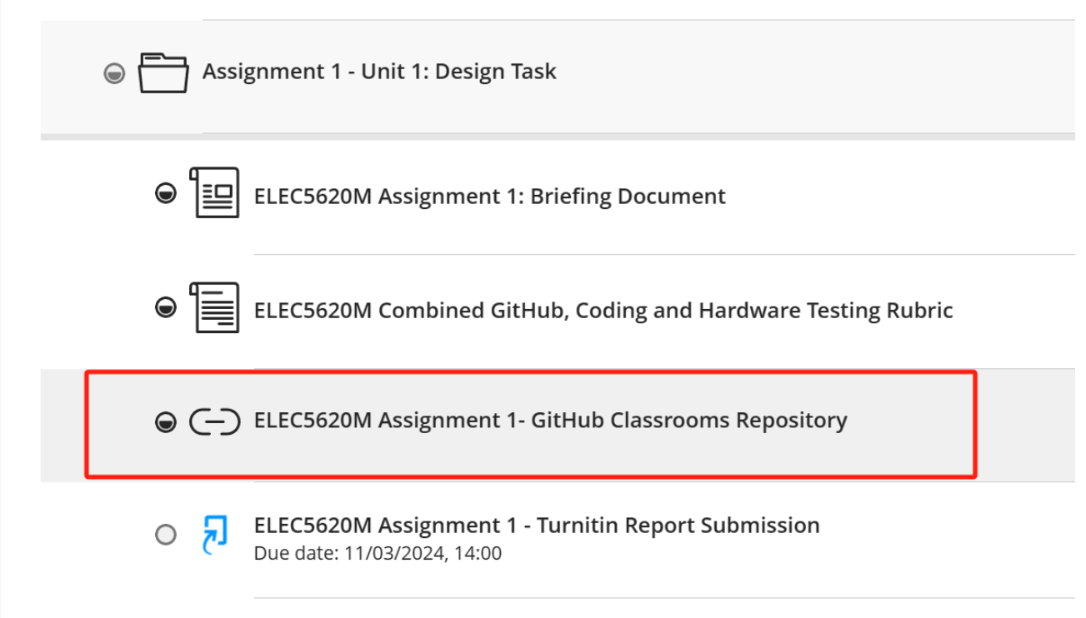

Figure 1

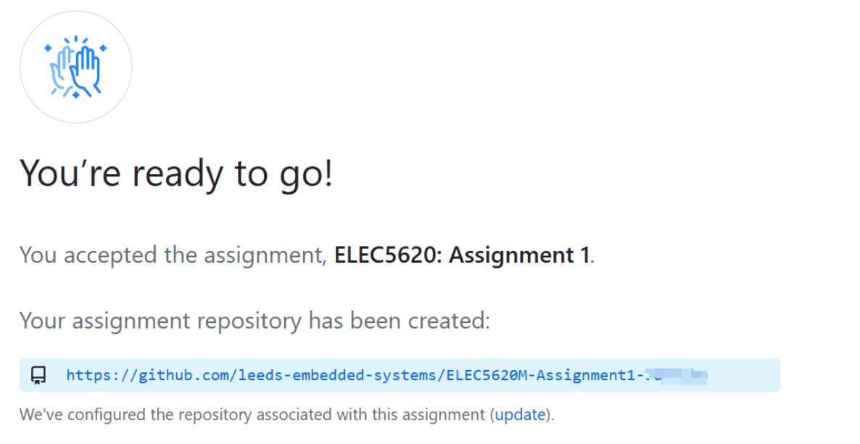

Figure 2

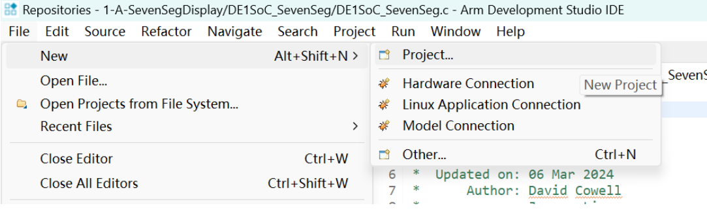

Figure 3

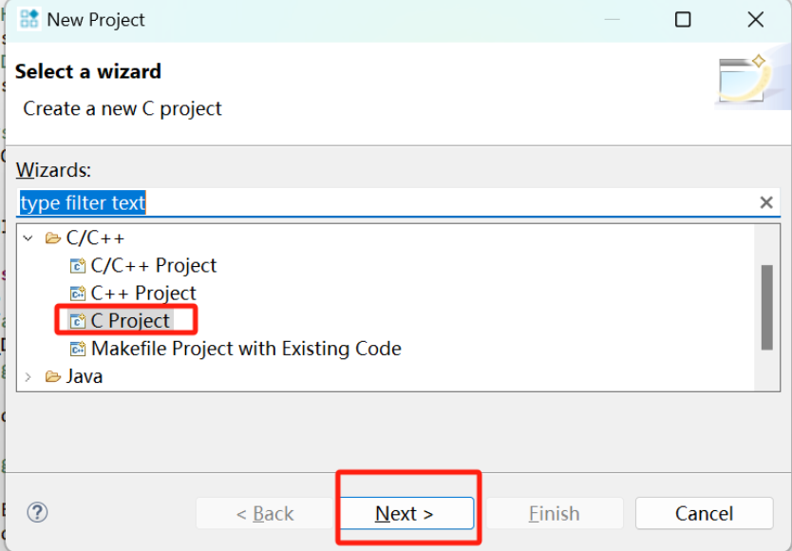

Figure 4

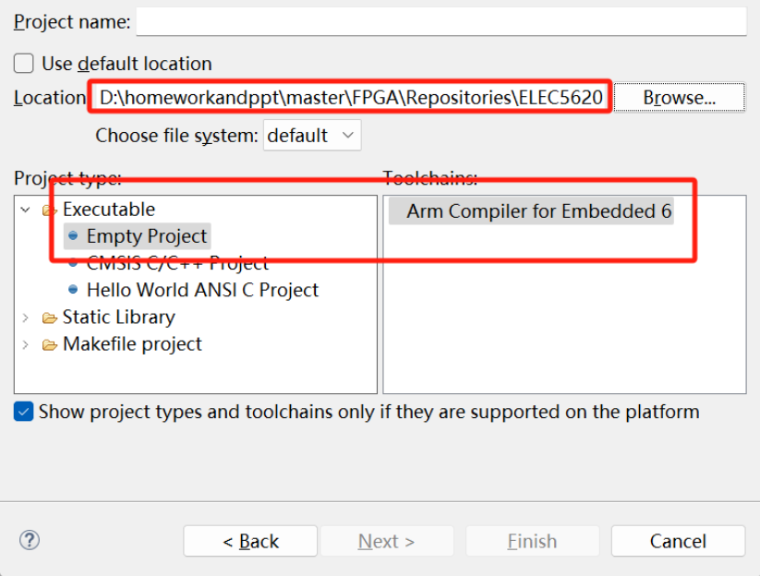

Figure 5

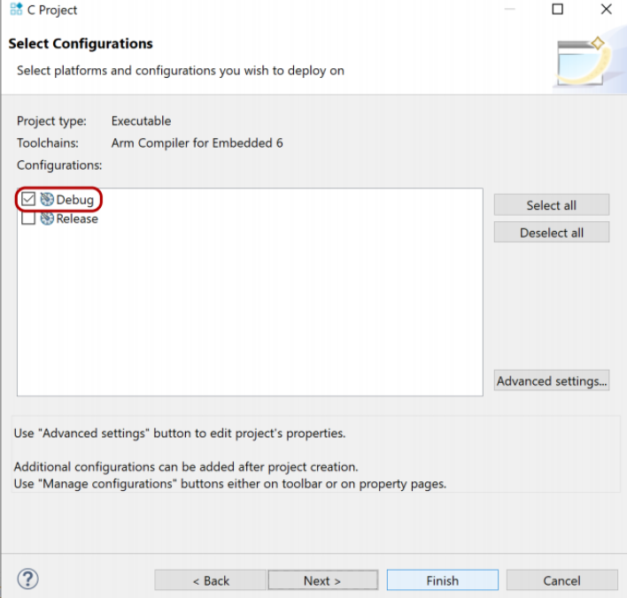

Figure 6

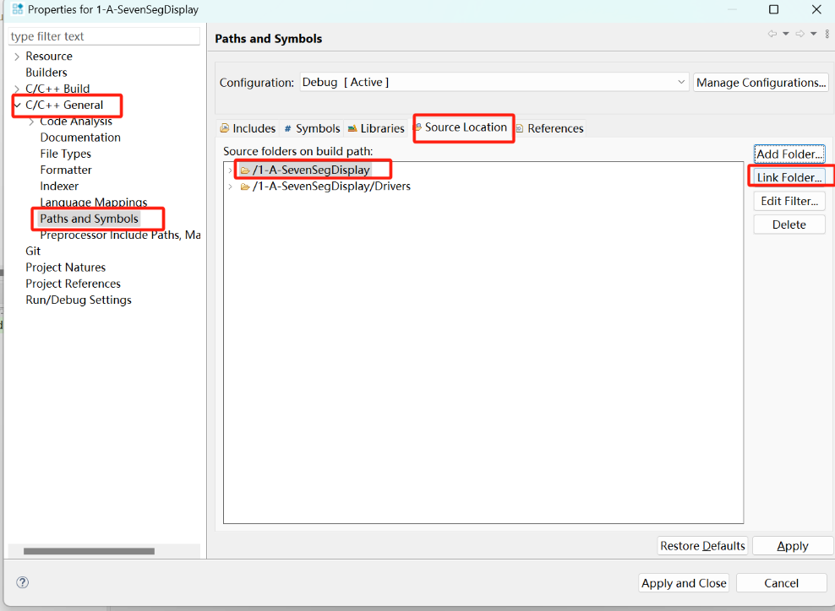

Figure 7

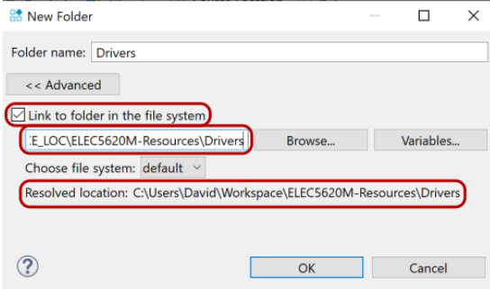

Figure 8

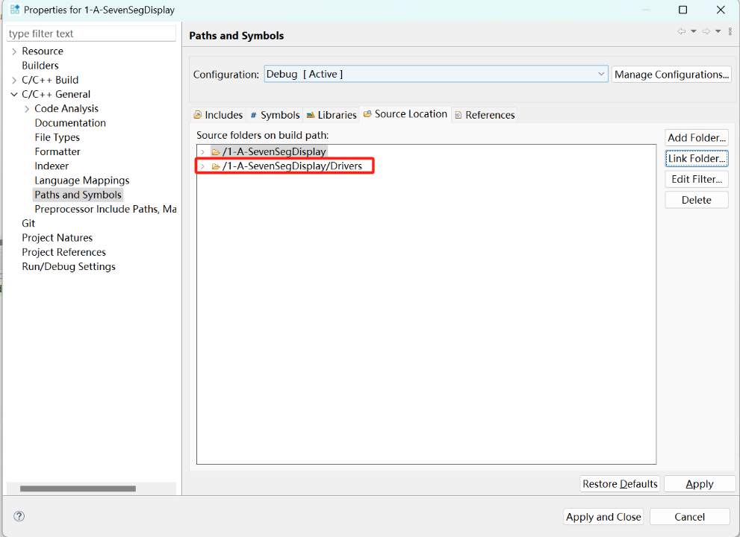

Figure 9

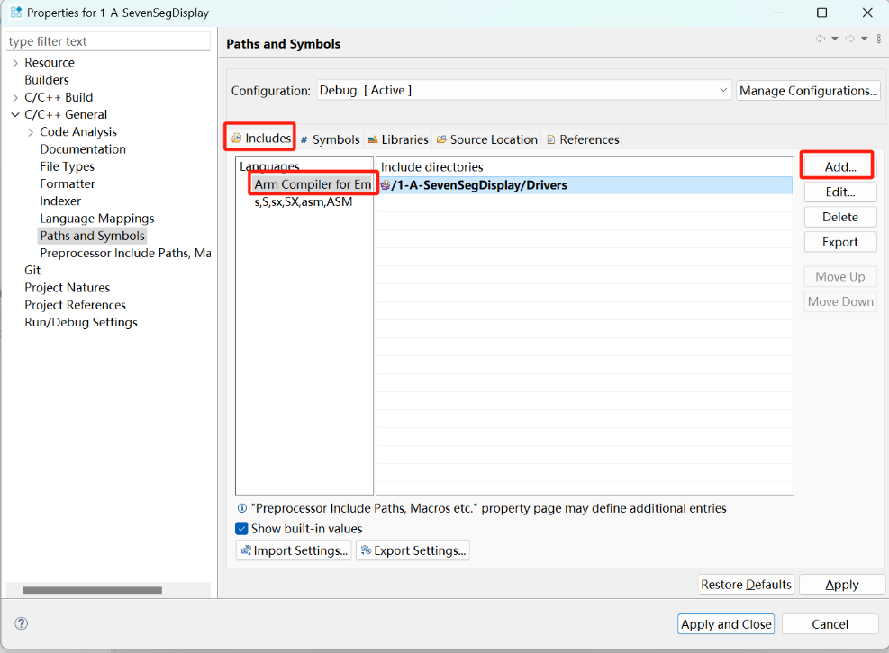

Figure 10

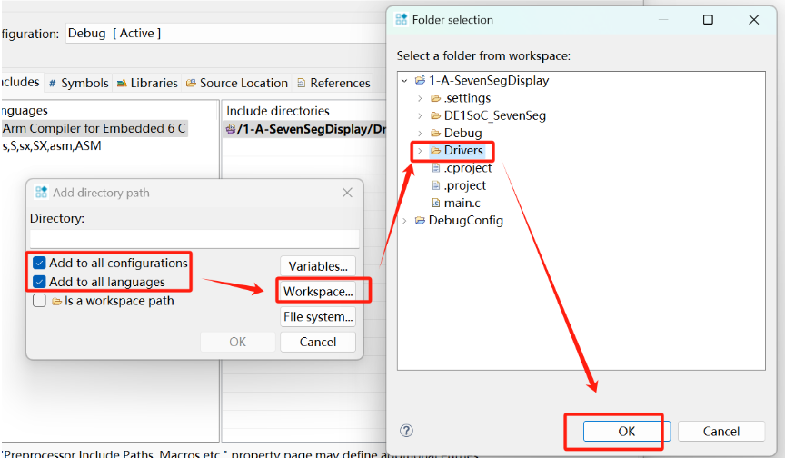

Figure 11

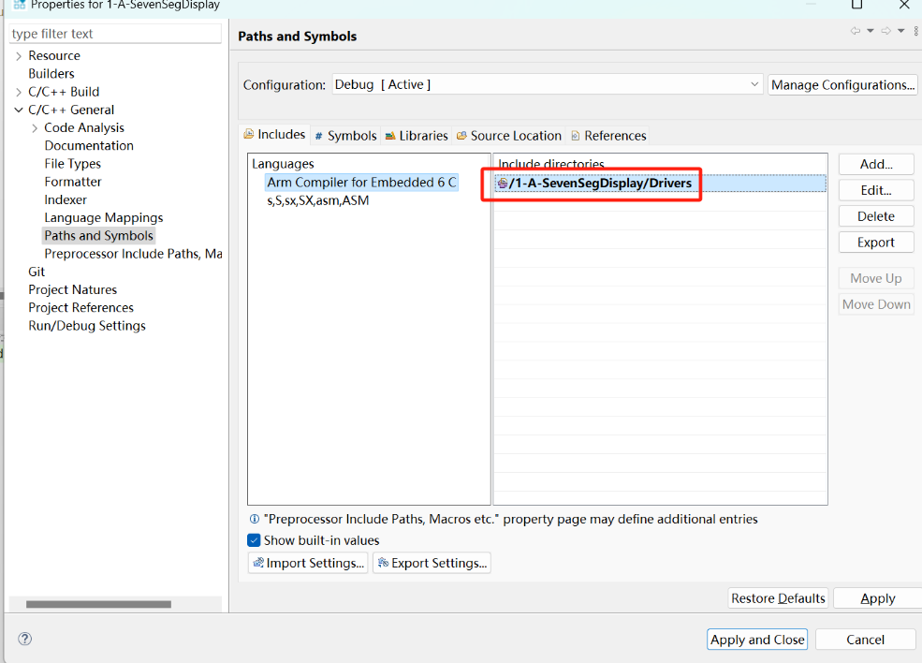

Figure 12

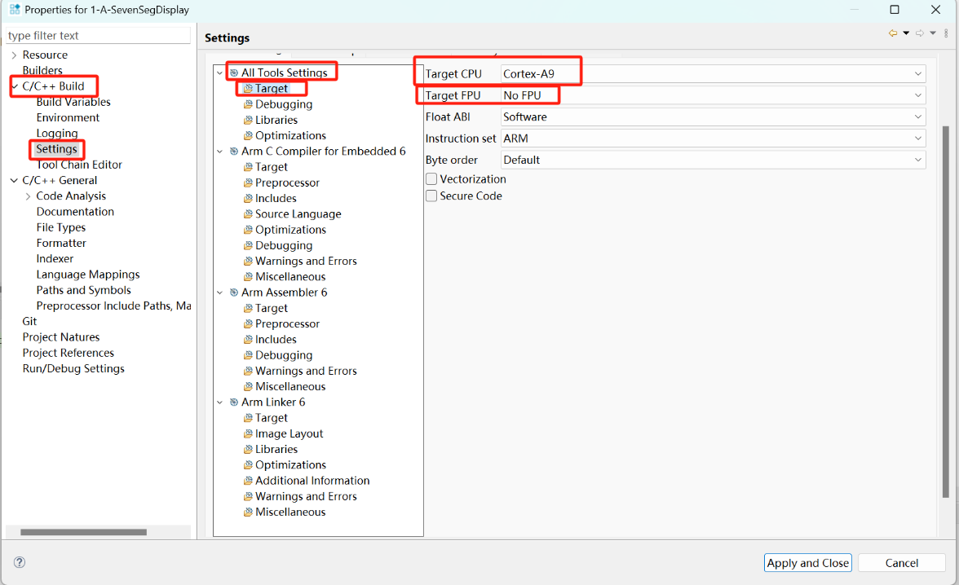

Figure 13

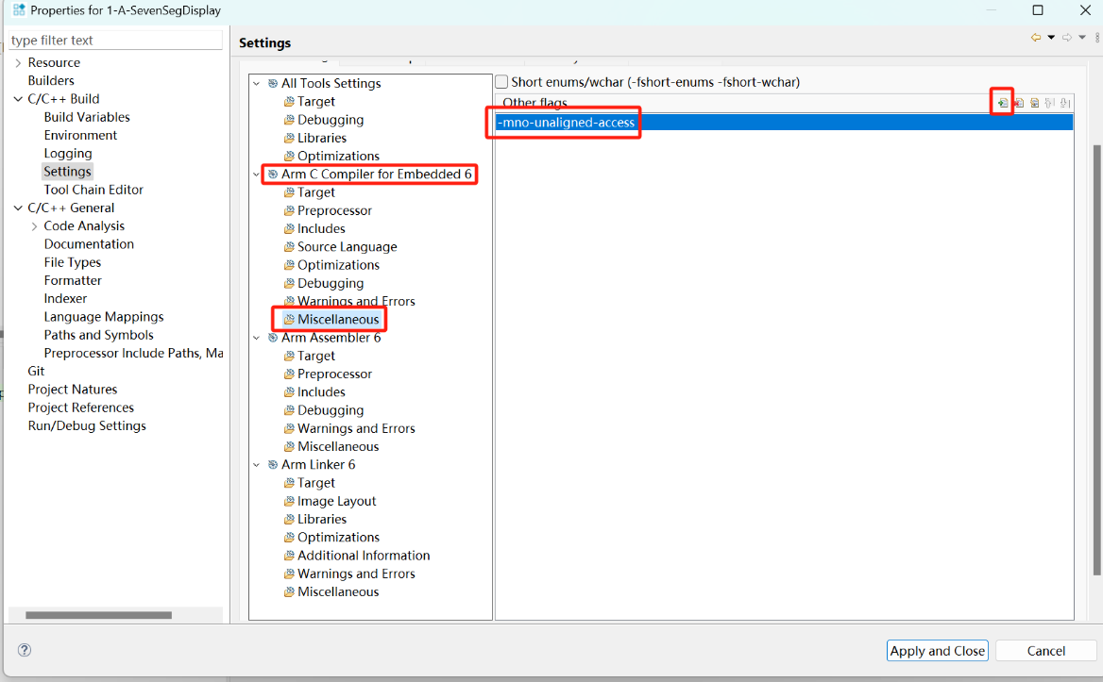

Figure 14

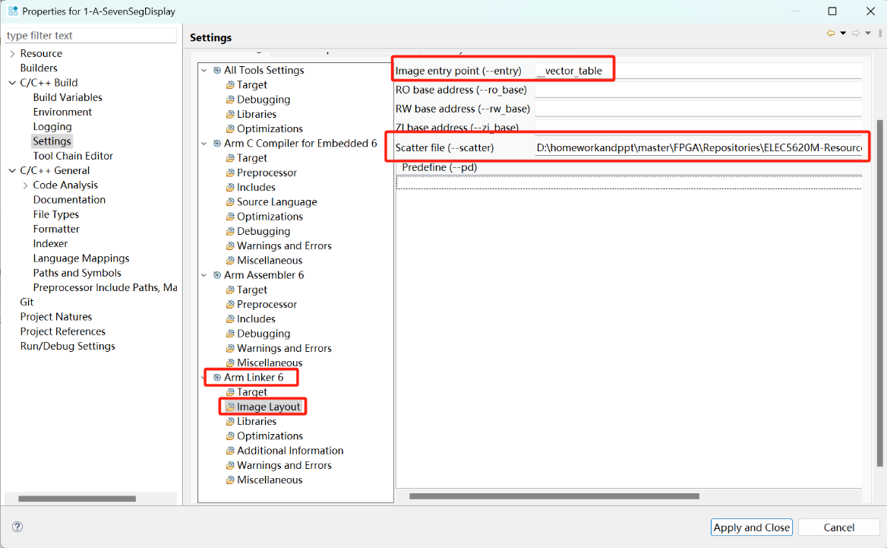

Figure 15

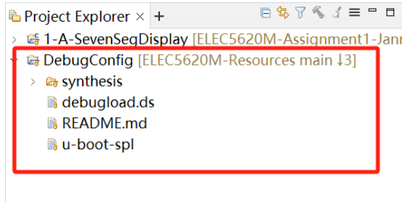

Figure 16

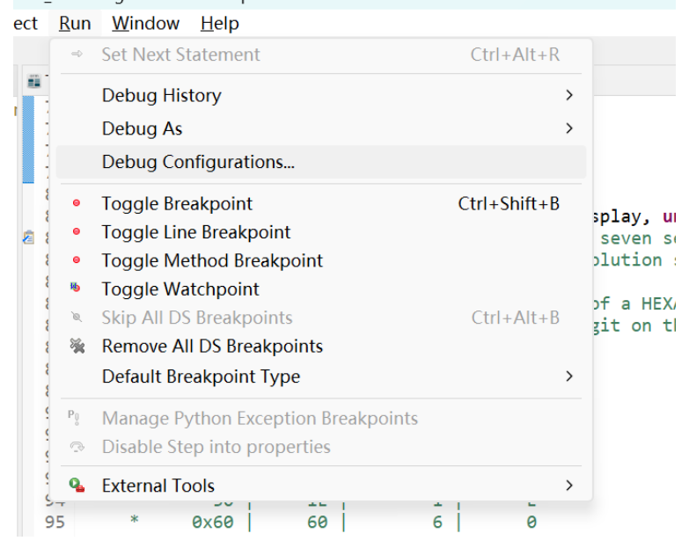

Figure 17

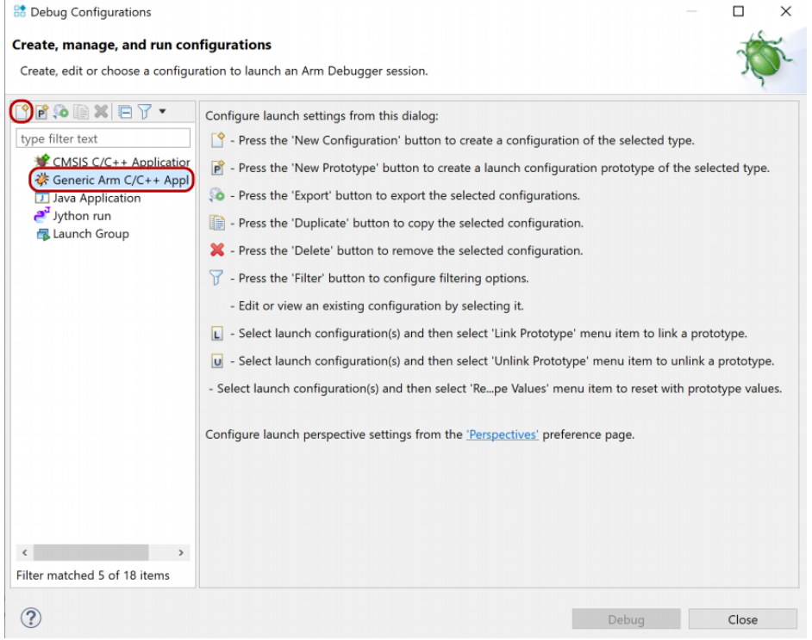

Figure 18

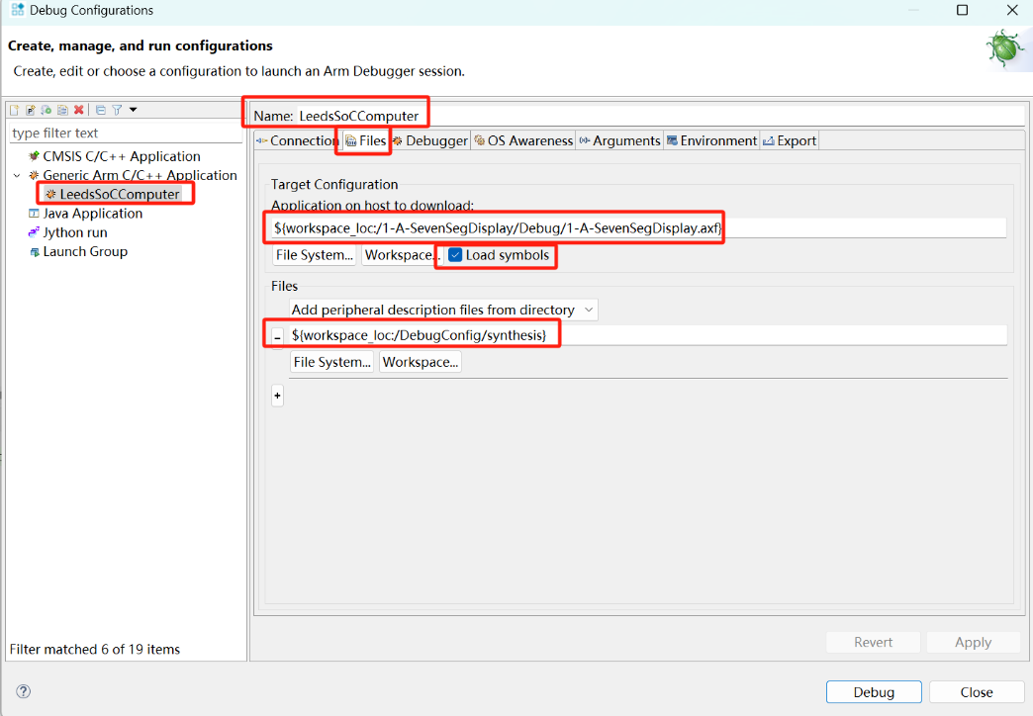

Figure 19

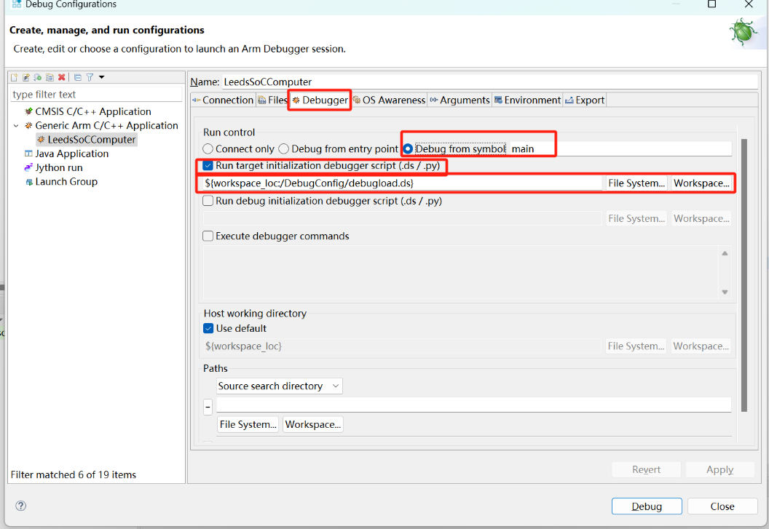

Figure 20

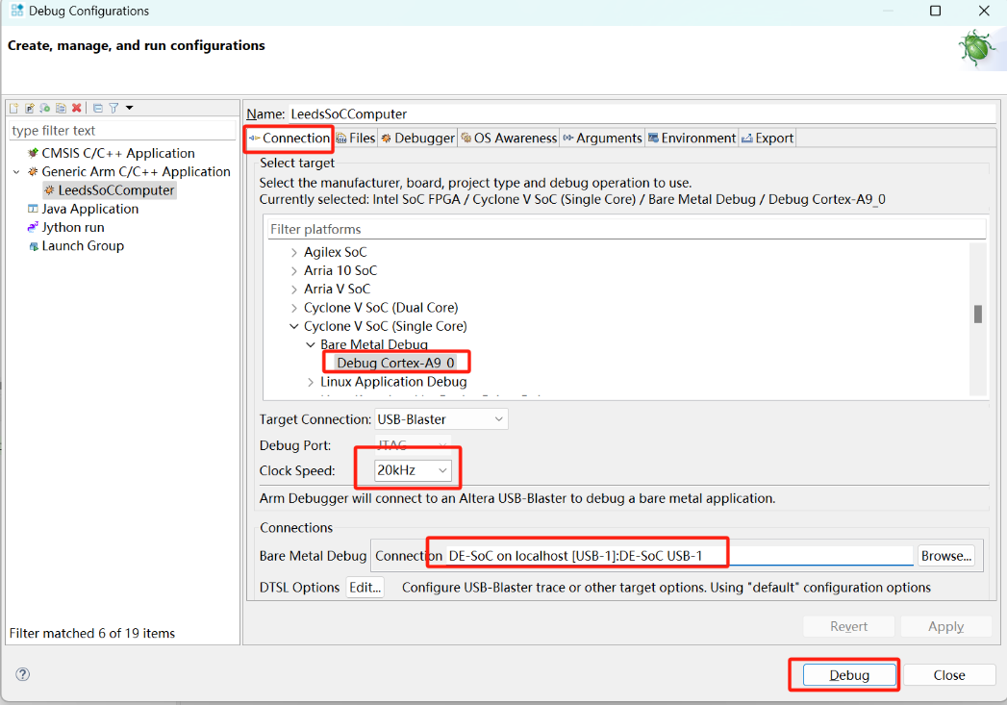

Figure 21

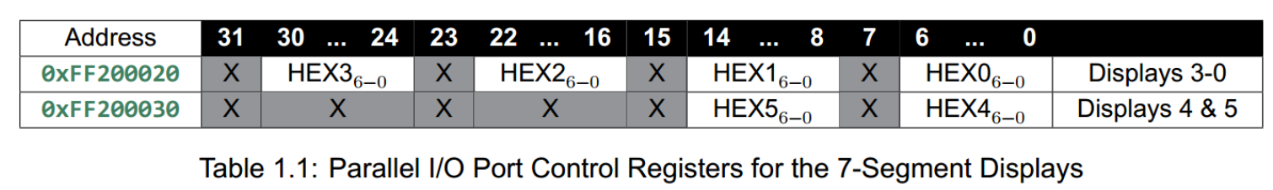

Figure 22

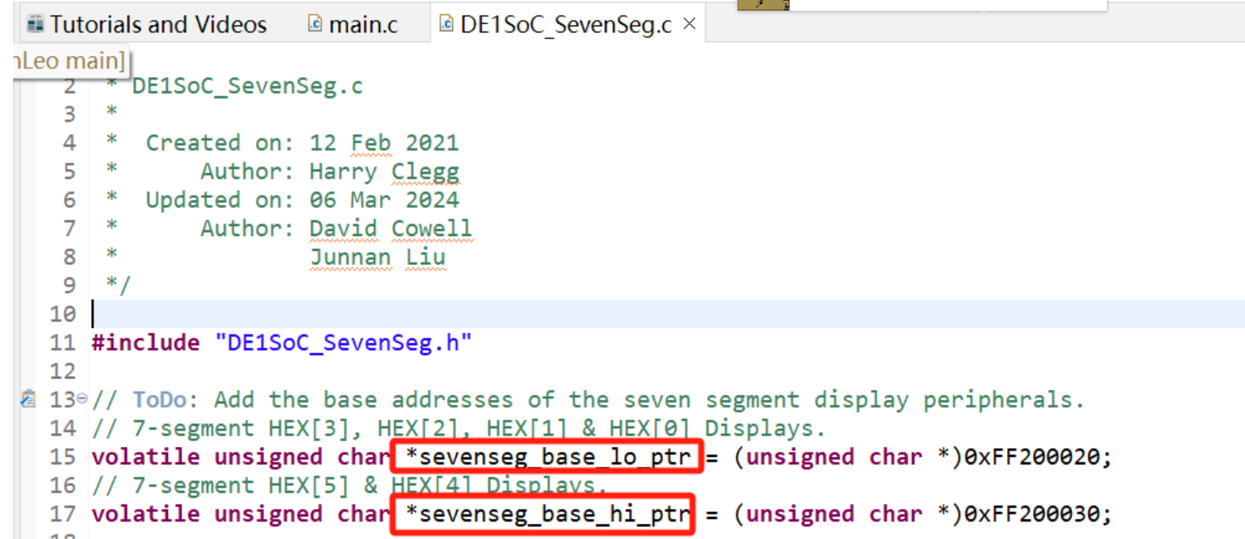

Figure 23

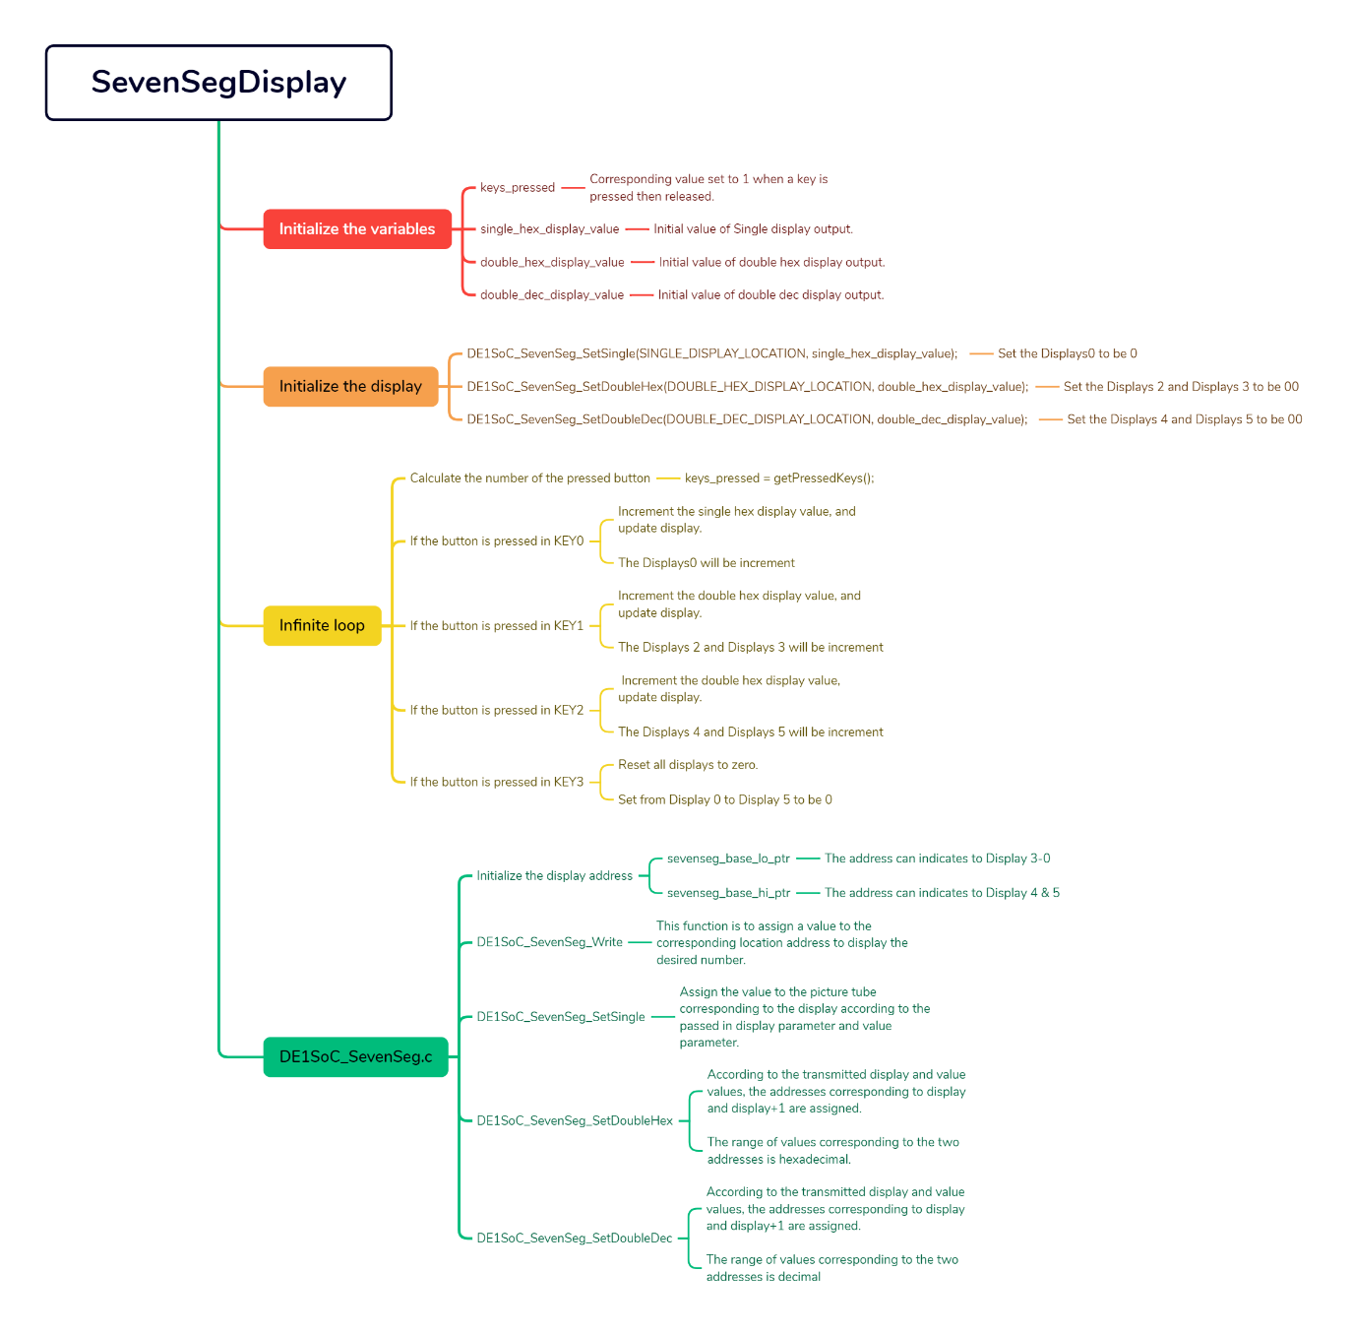

Figure 24

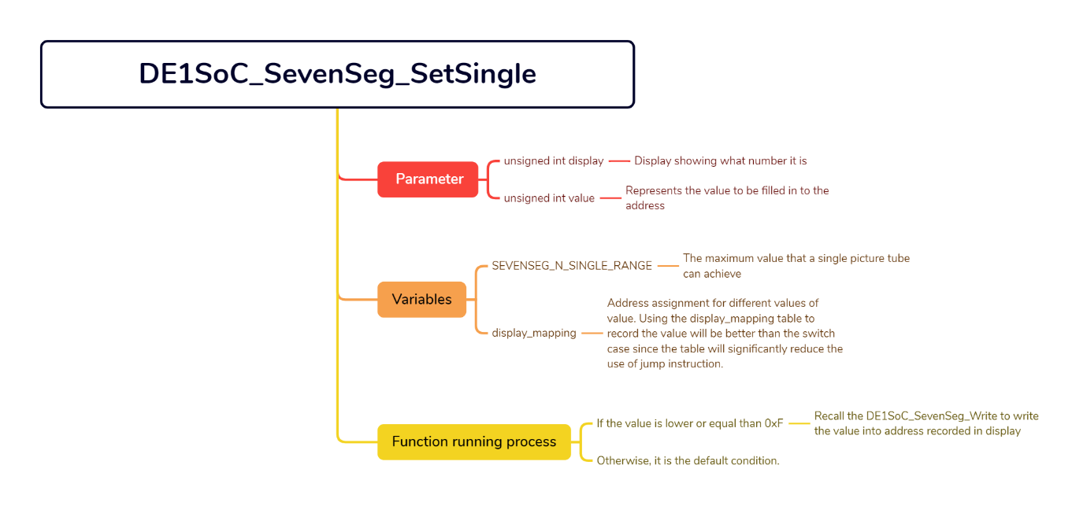

Figure 25

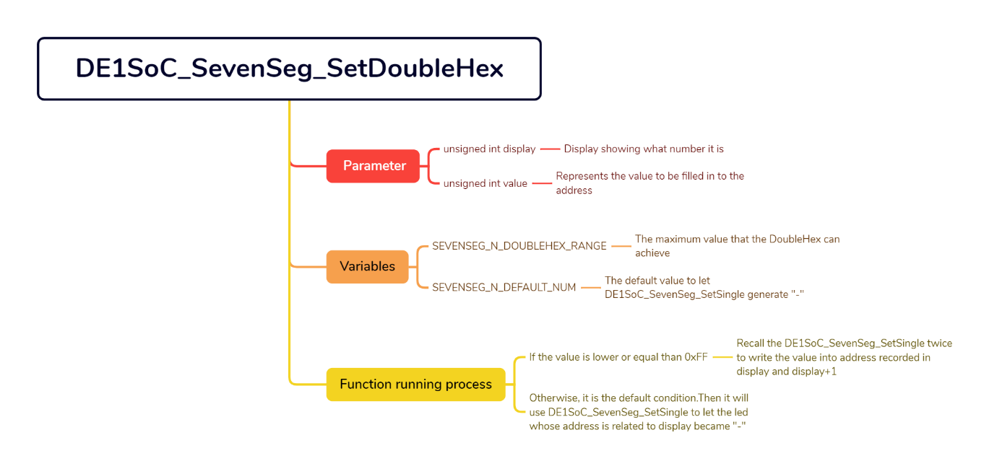

Figure 26

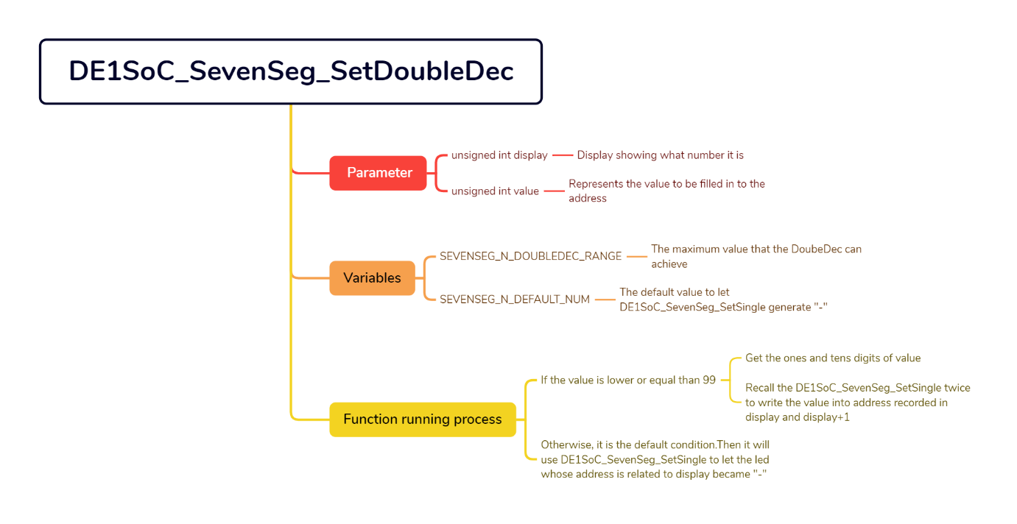

Figure 27

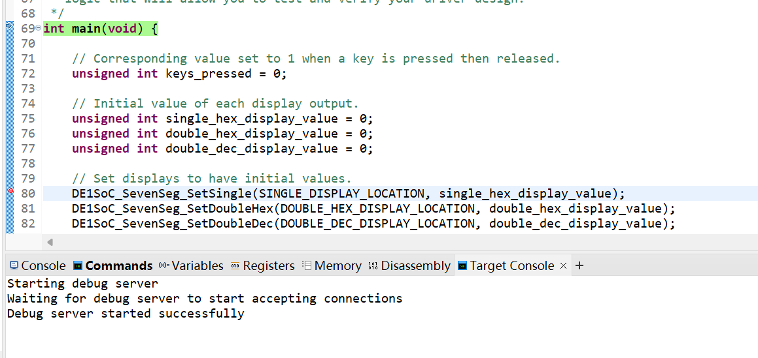

Figure 28

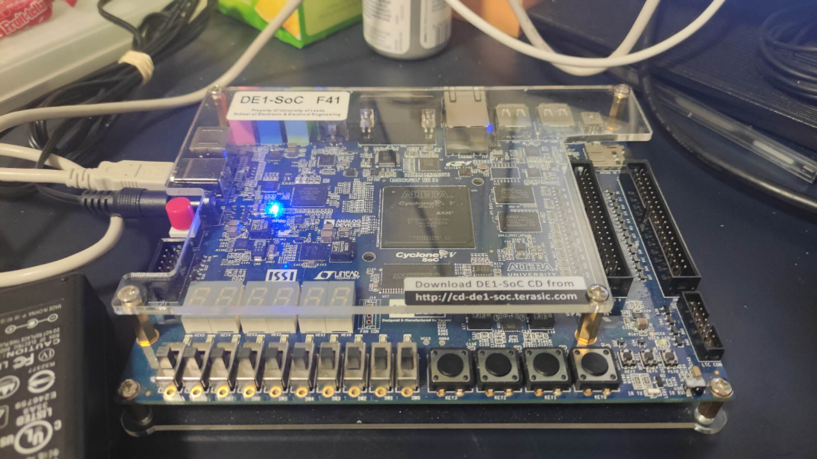

Figure 29

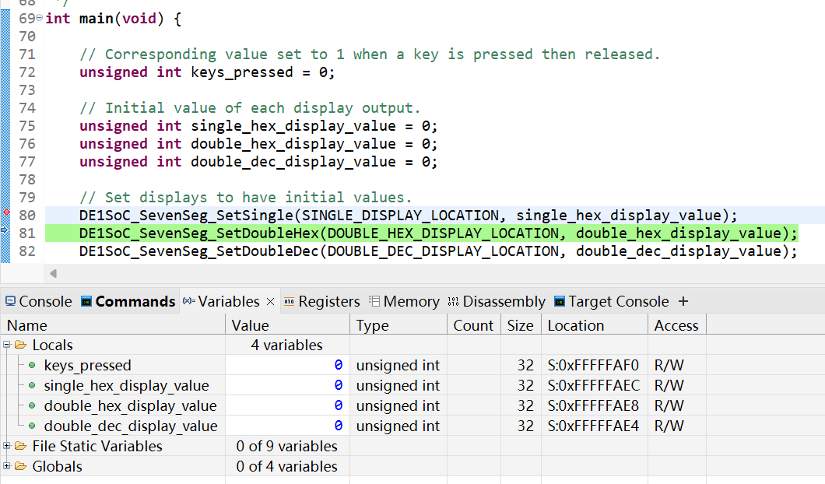

Figure 30

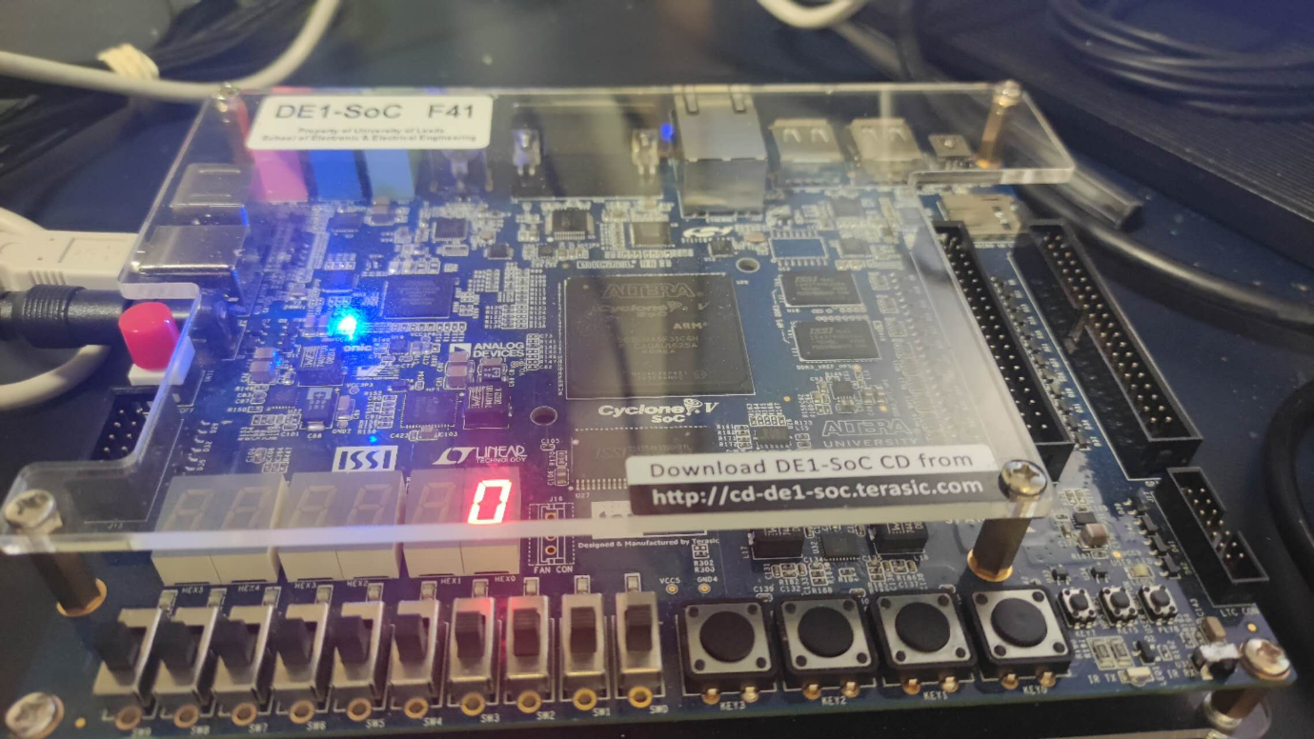

Figure 31

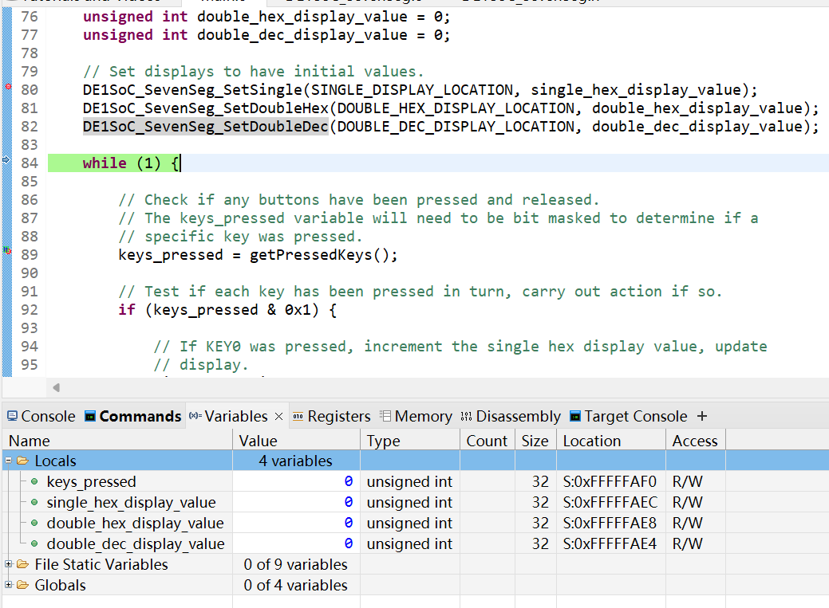

Figure 32

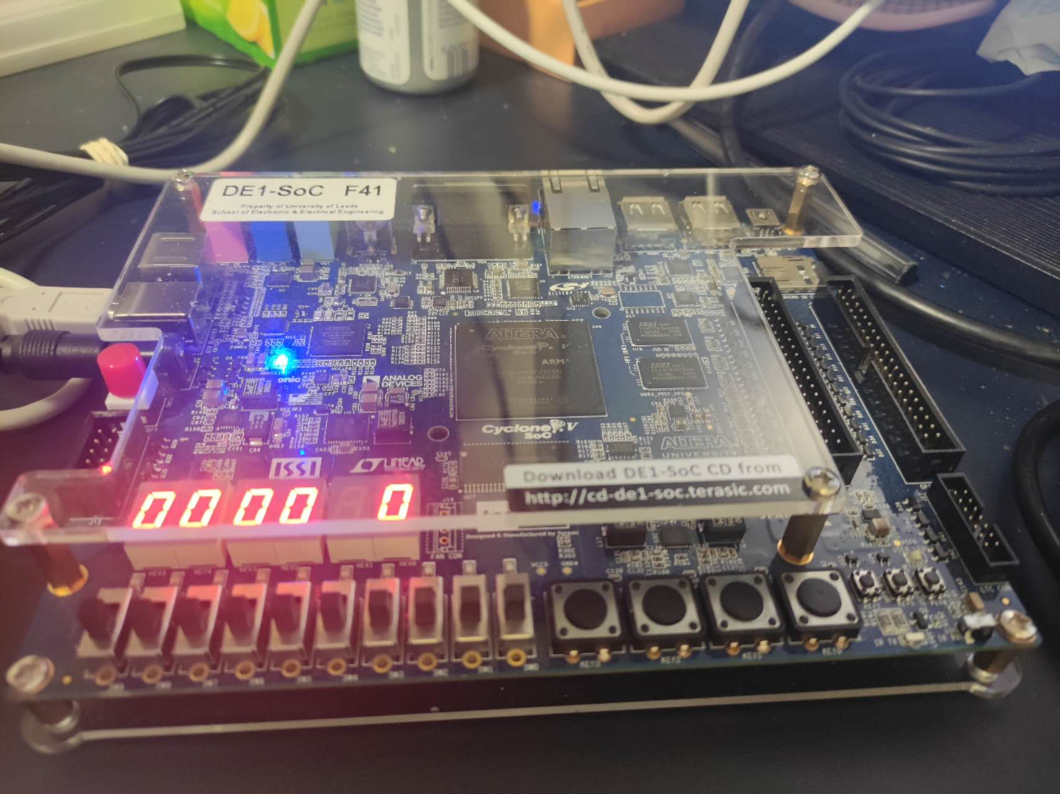

Figure 33

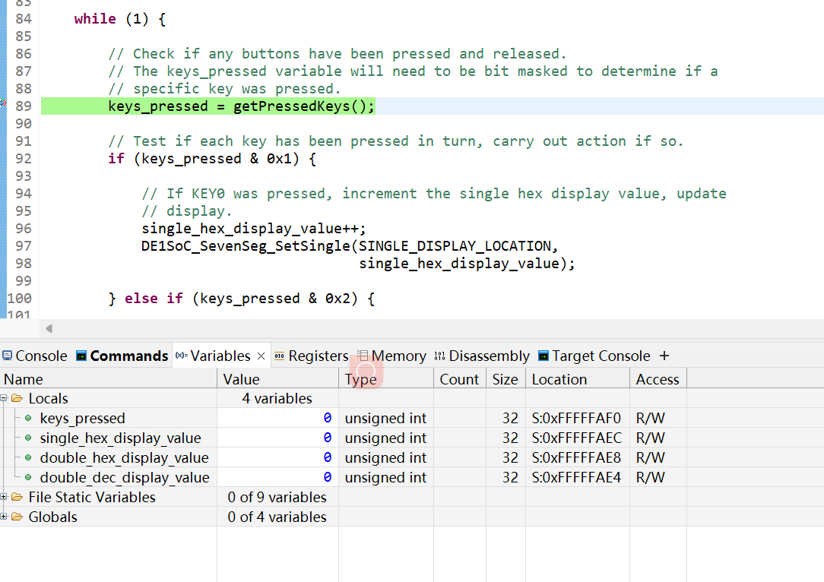

Figure 34

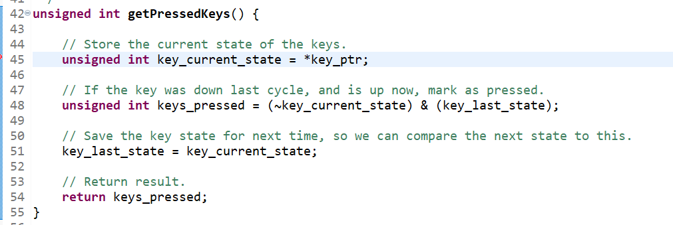

Figure 35

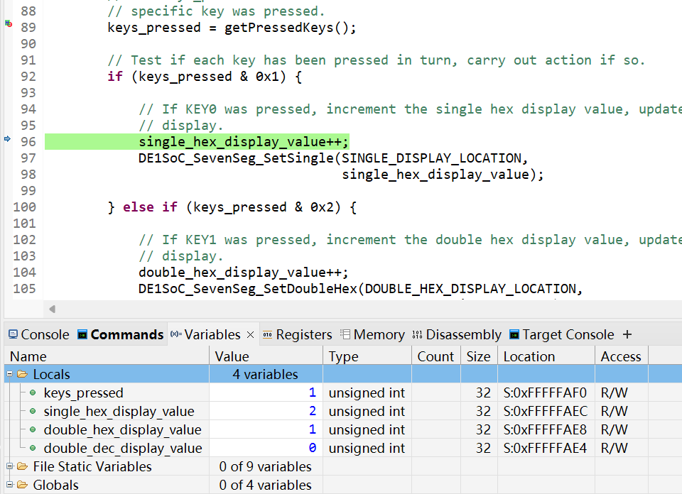

Figure 36

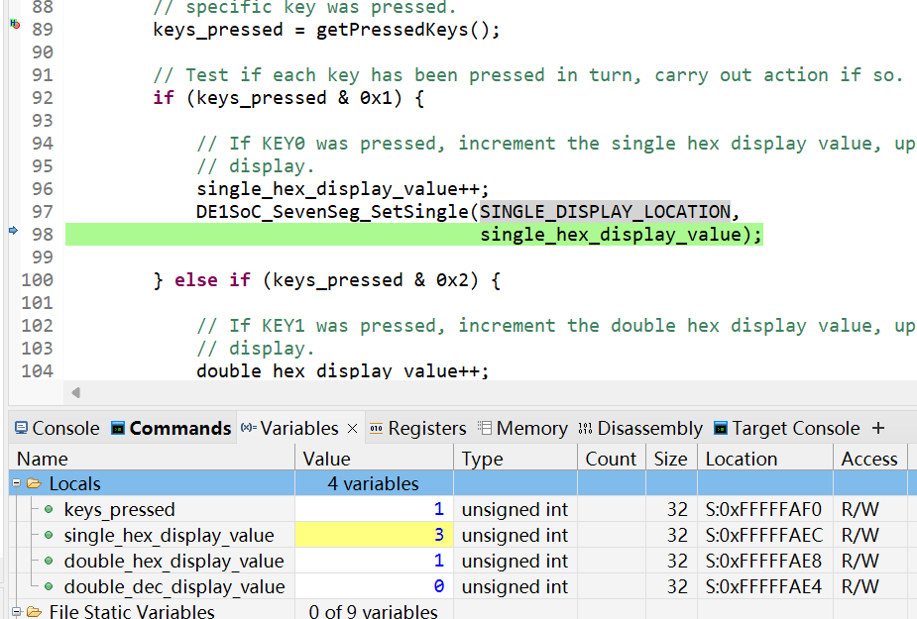

Figure 37

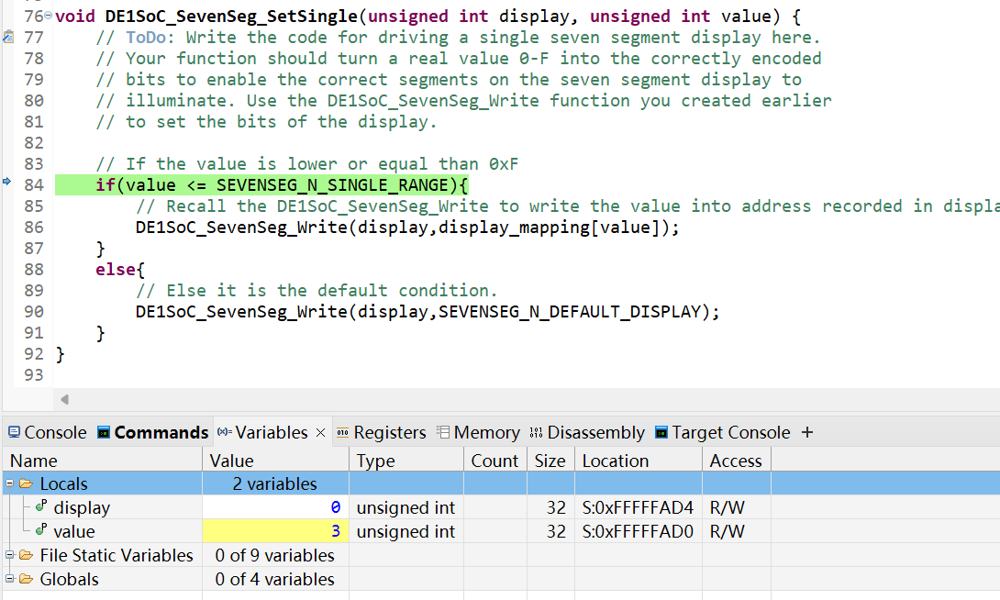

Figure 38

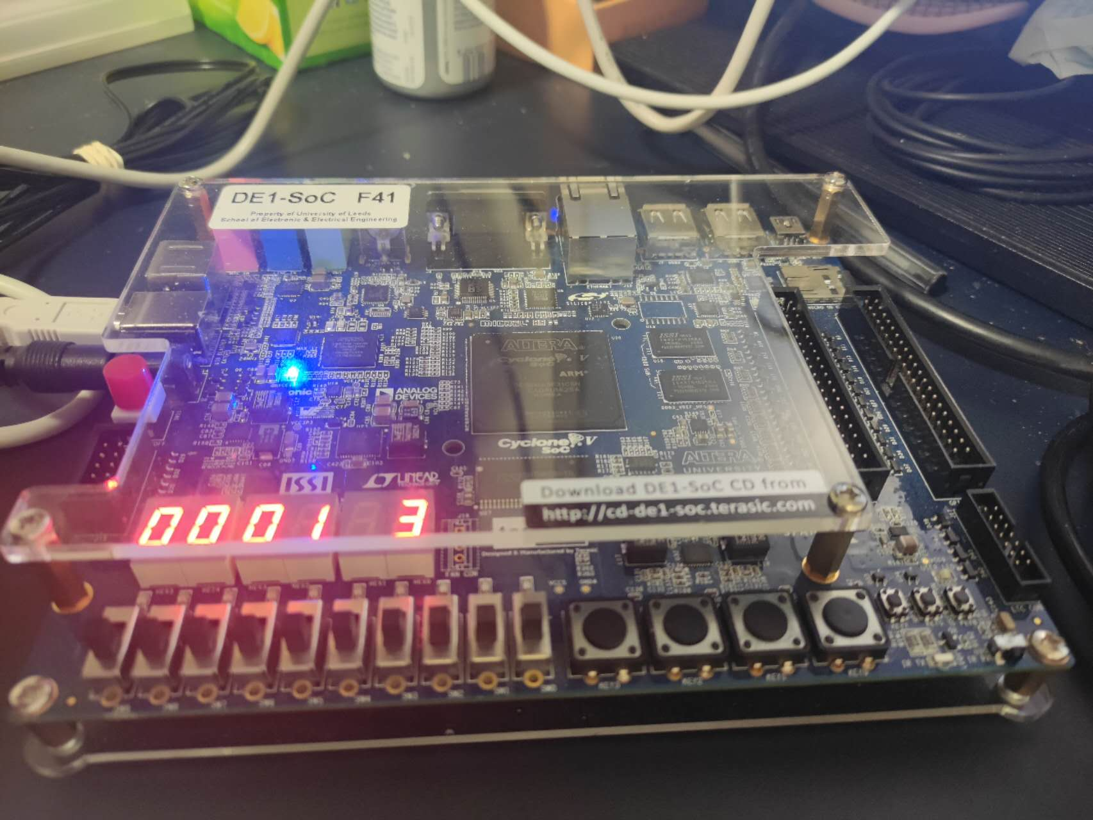

Figure 39

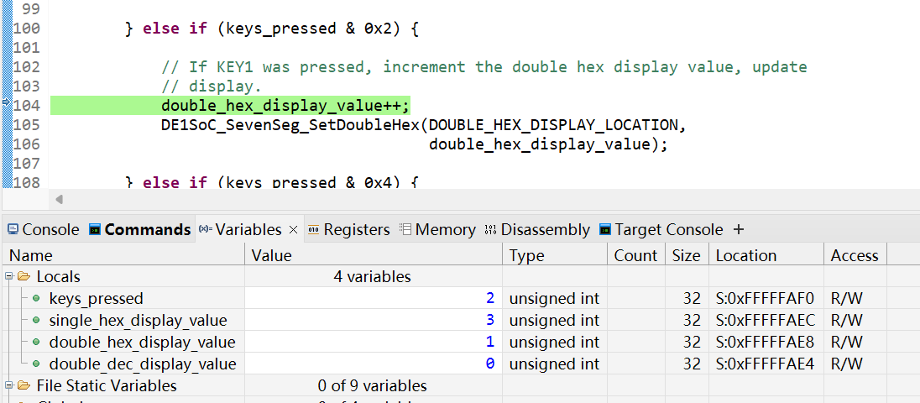

Figure 40

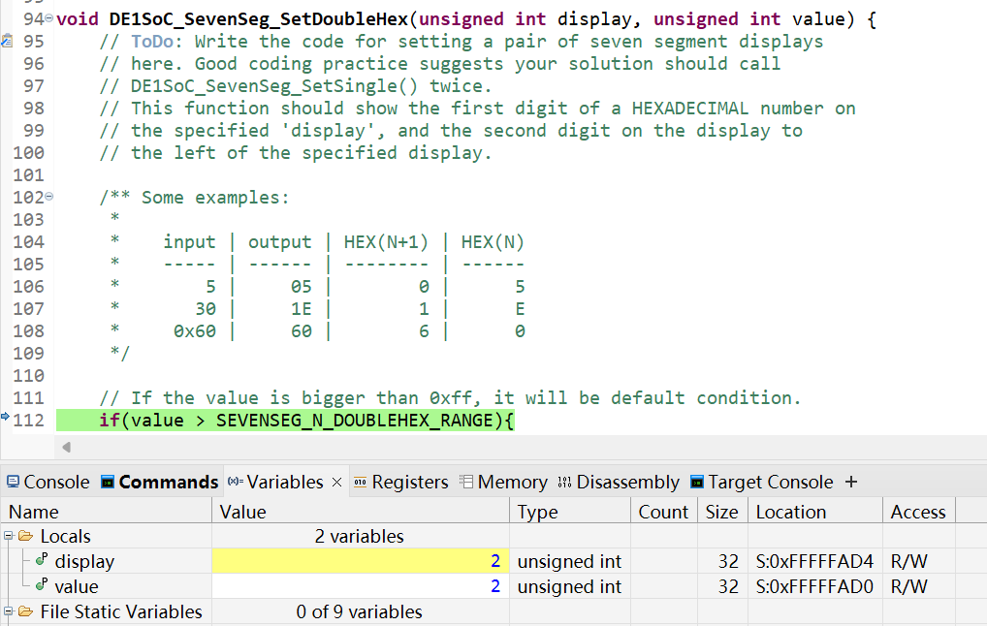

Figure 41

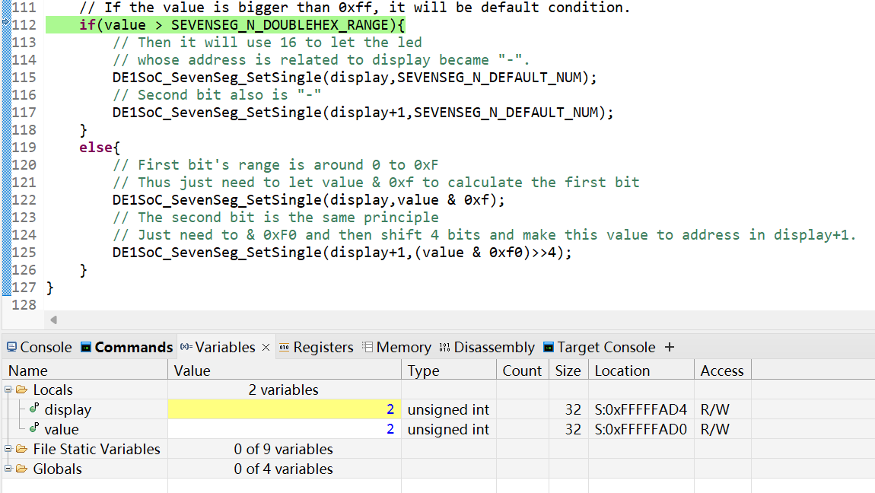

Figure 42

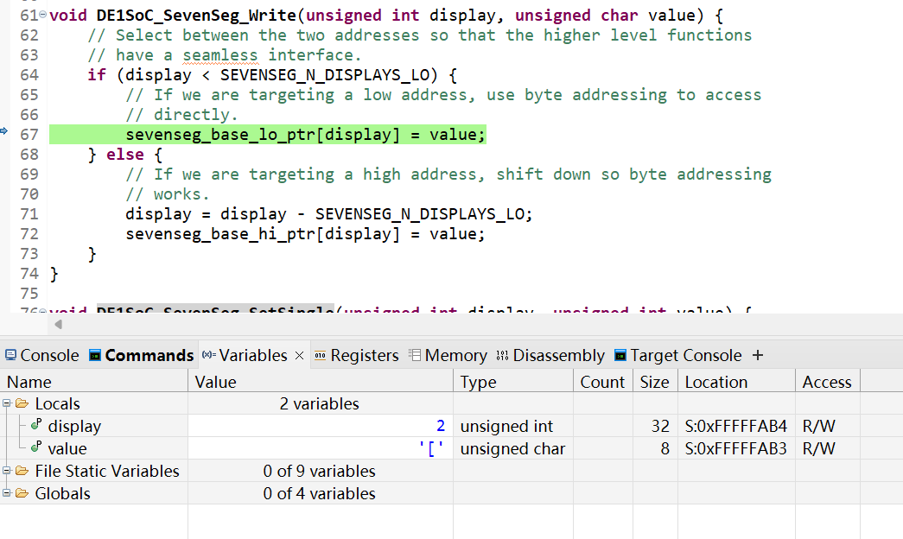

Figure 43

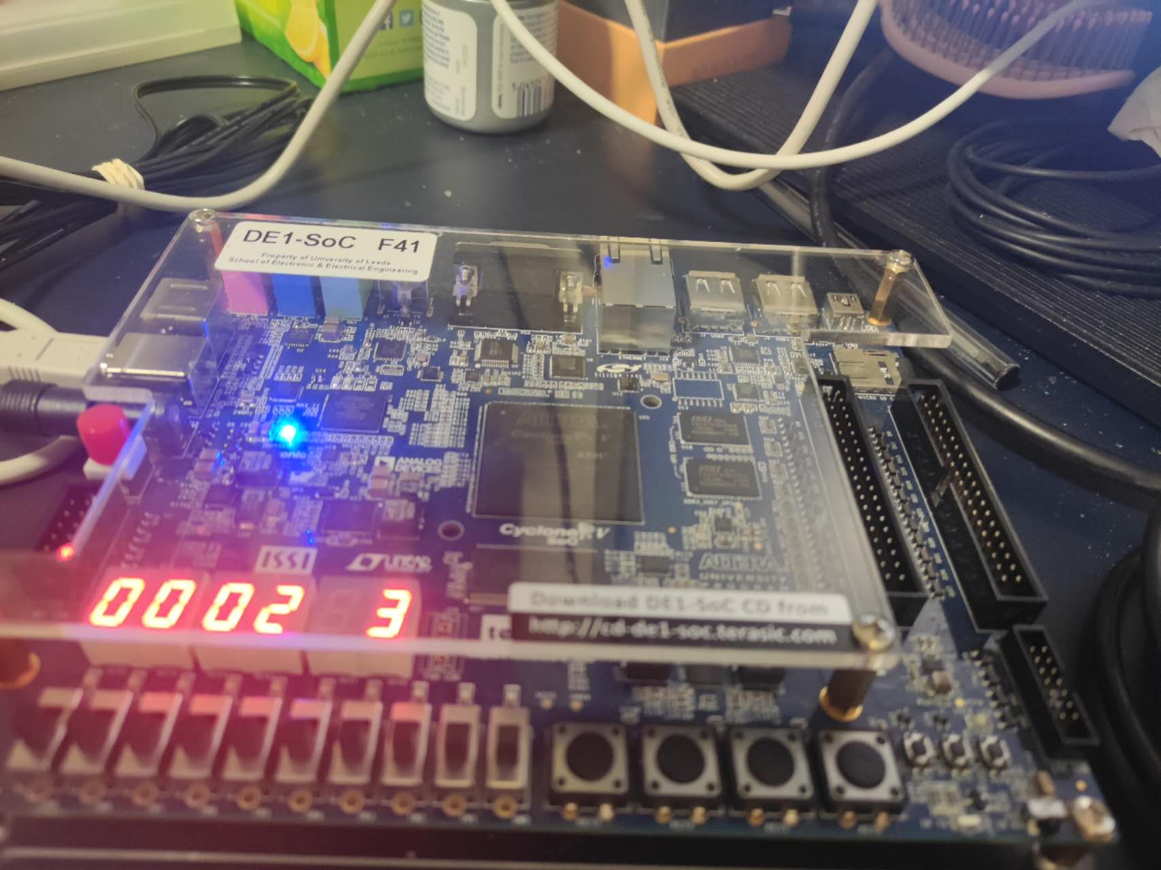

Figure 44

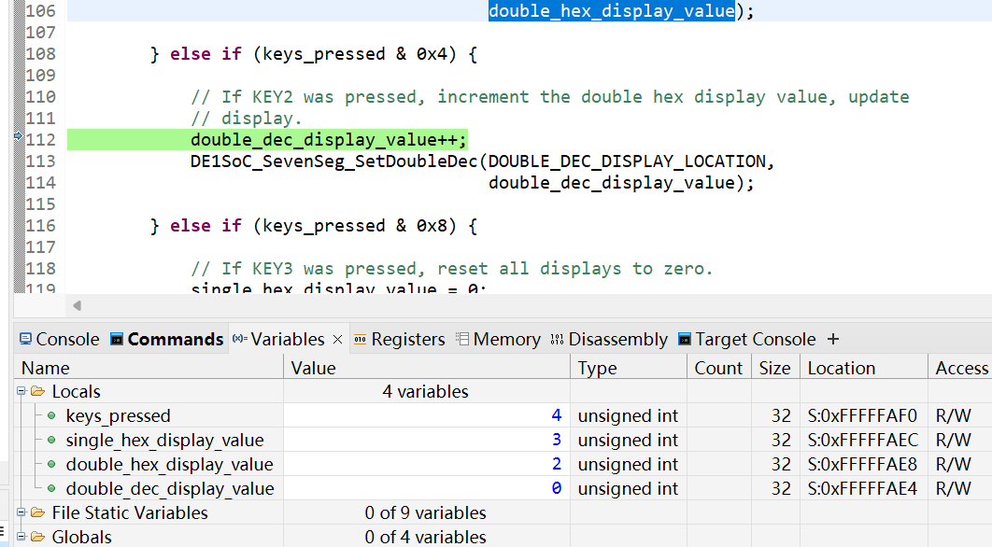

Figure 45



Figure 46

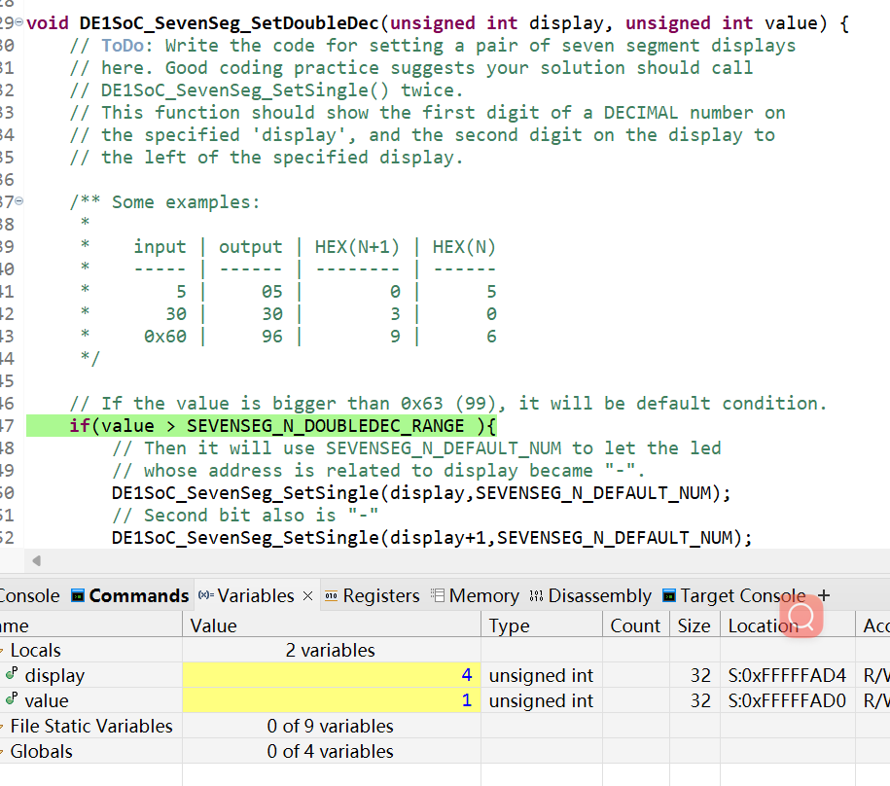

Figure 47

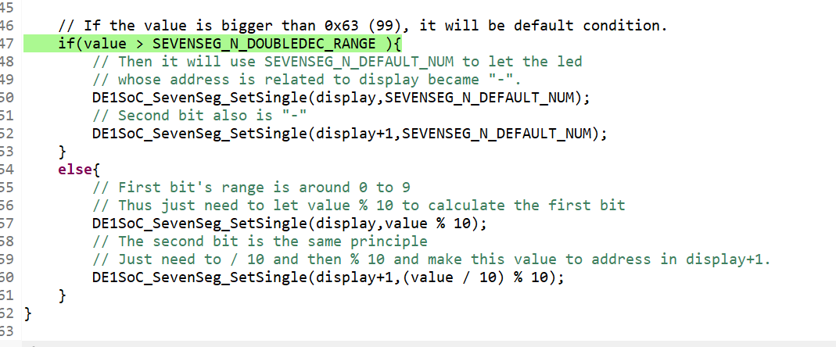

Figure 48

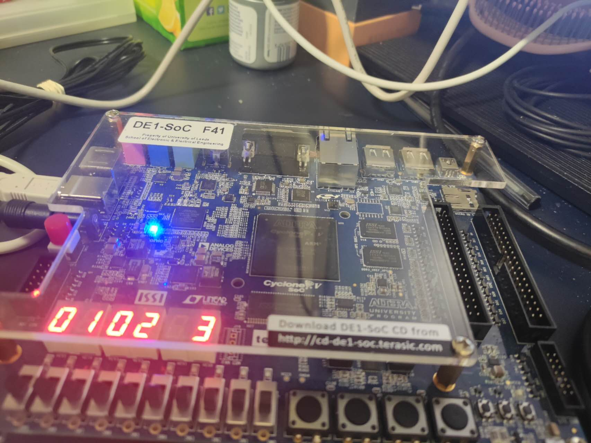

Figure 49

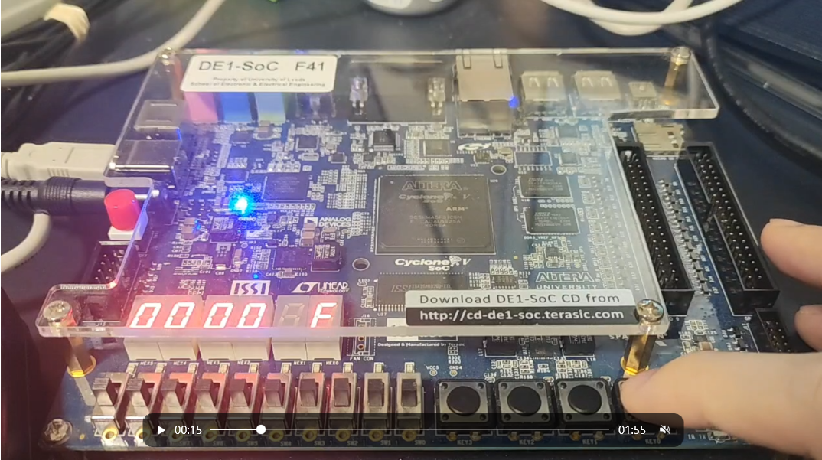

Figure 50

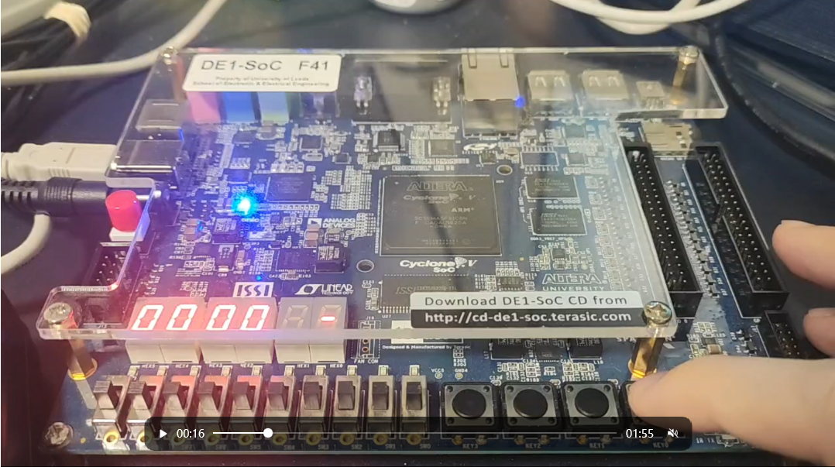

Figure 51

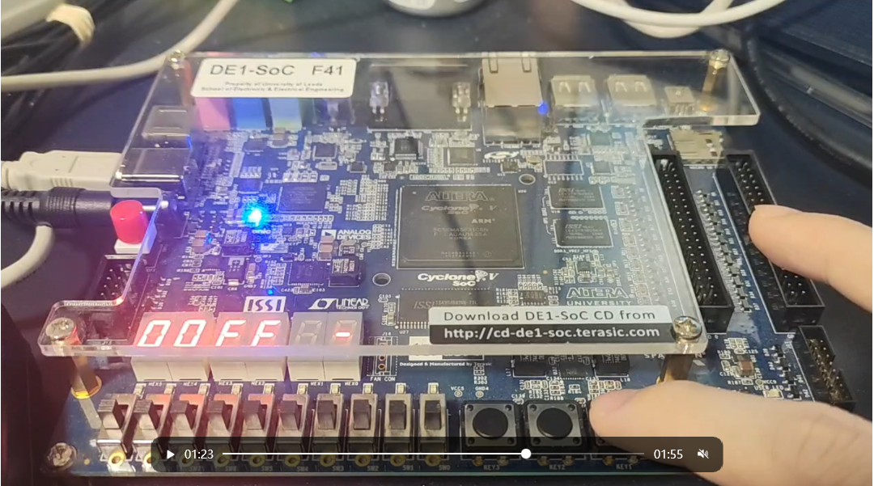

Figure 52

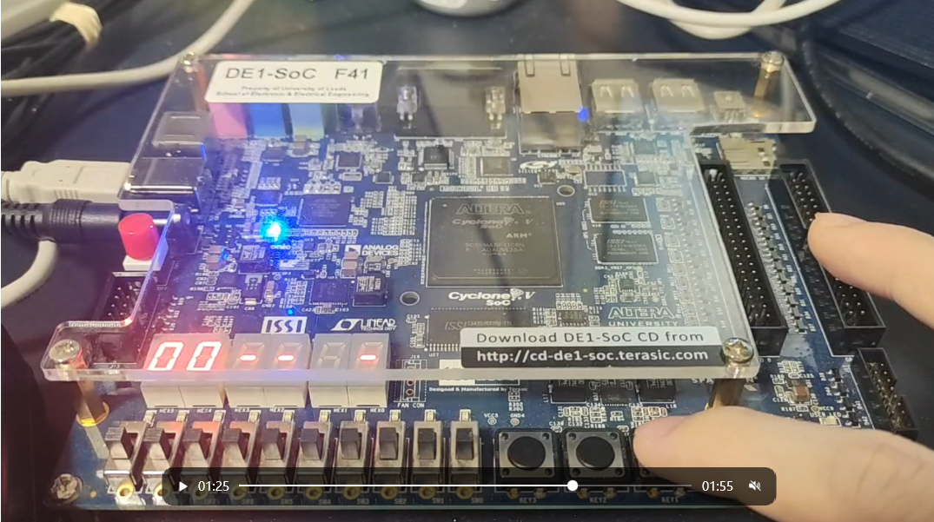

Figure 53

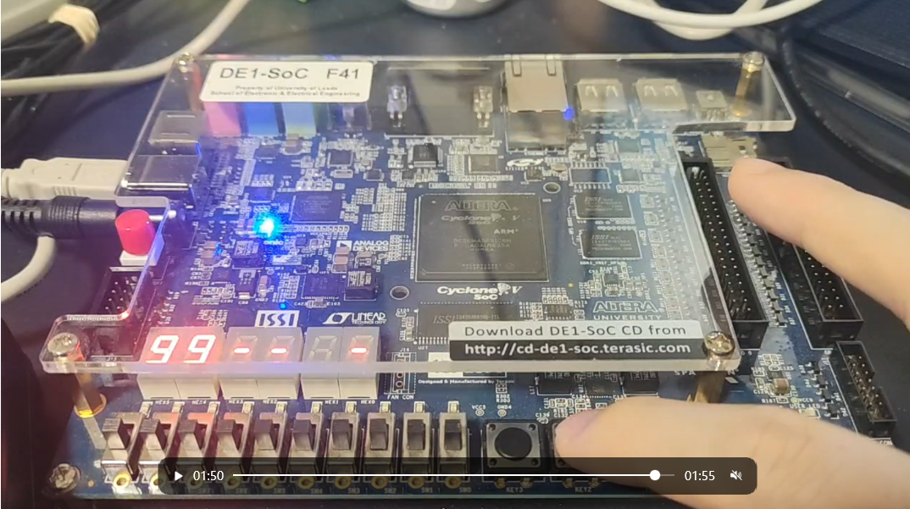

Figure 54

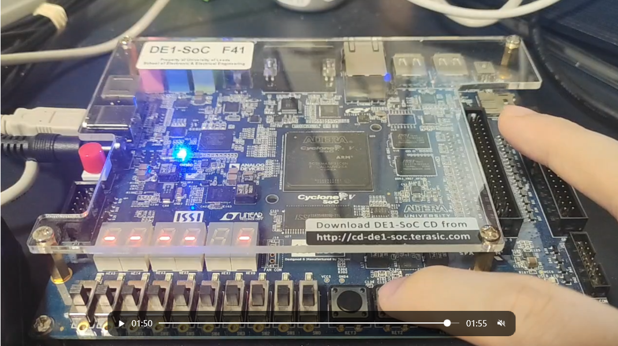

Figure 55

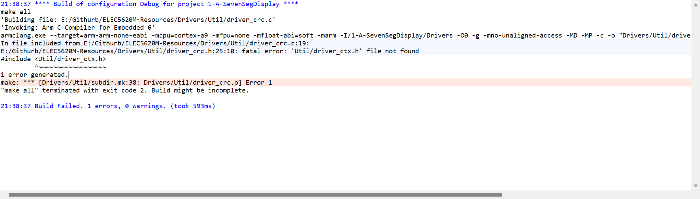

Figure 56

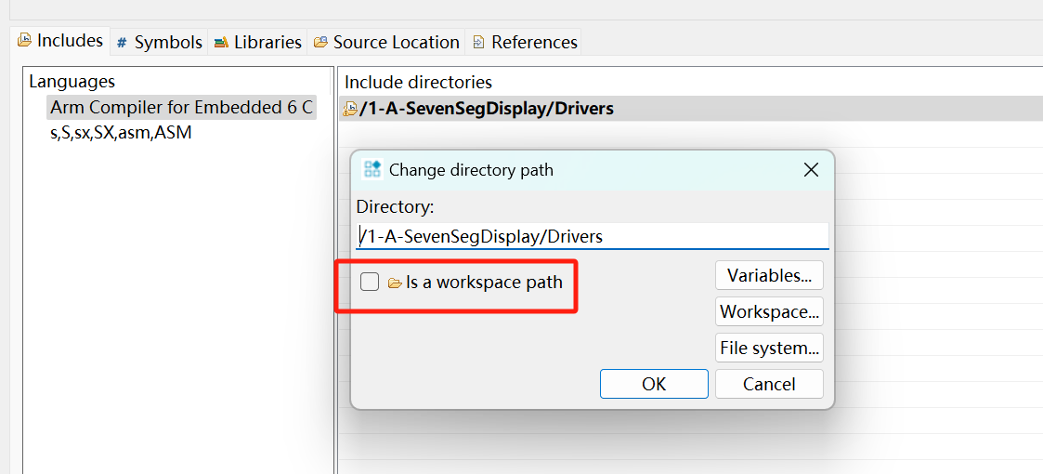

Figure 57

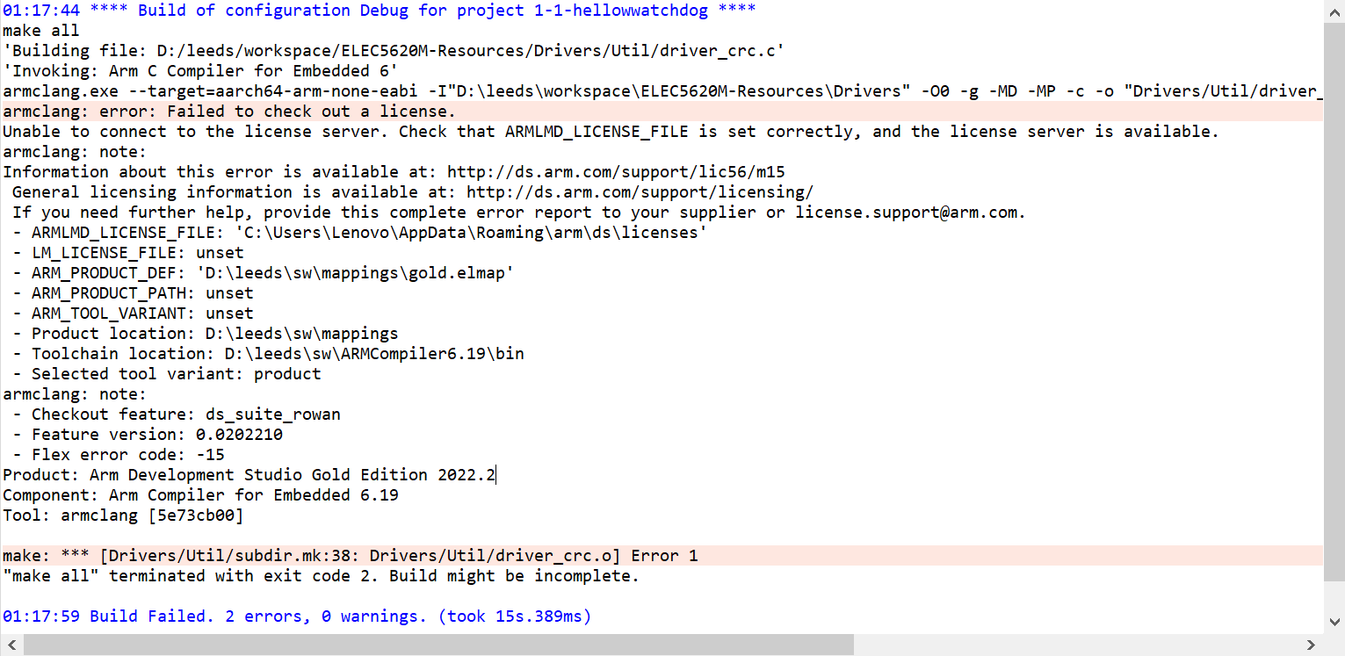

Figure 58

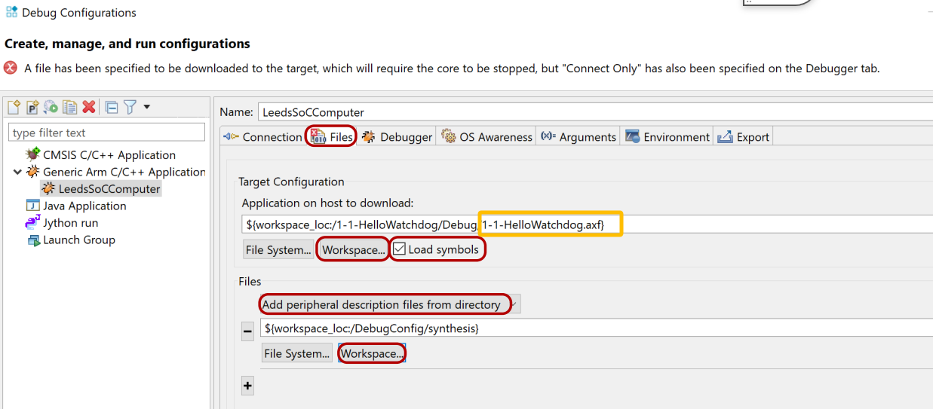

Figure 59

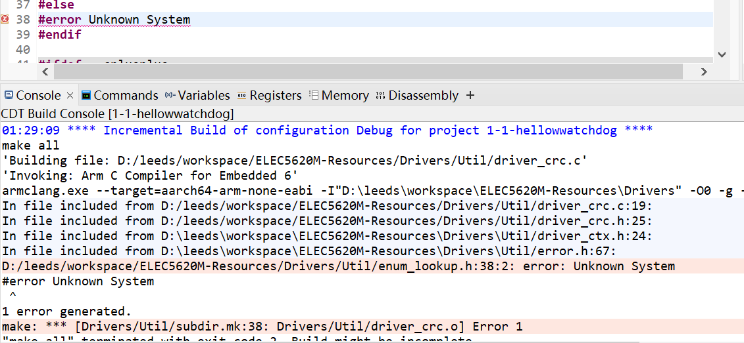

Figure 60

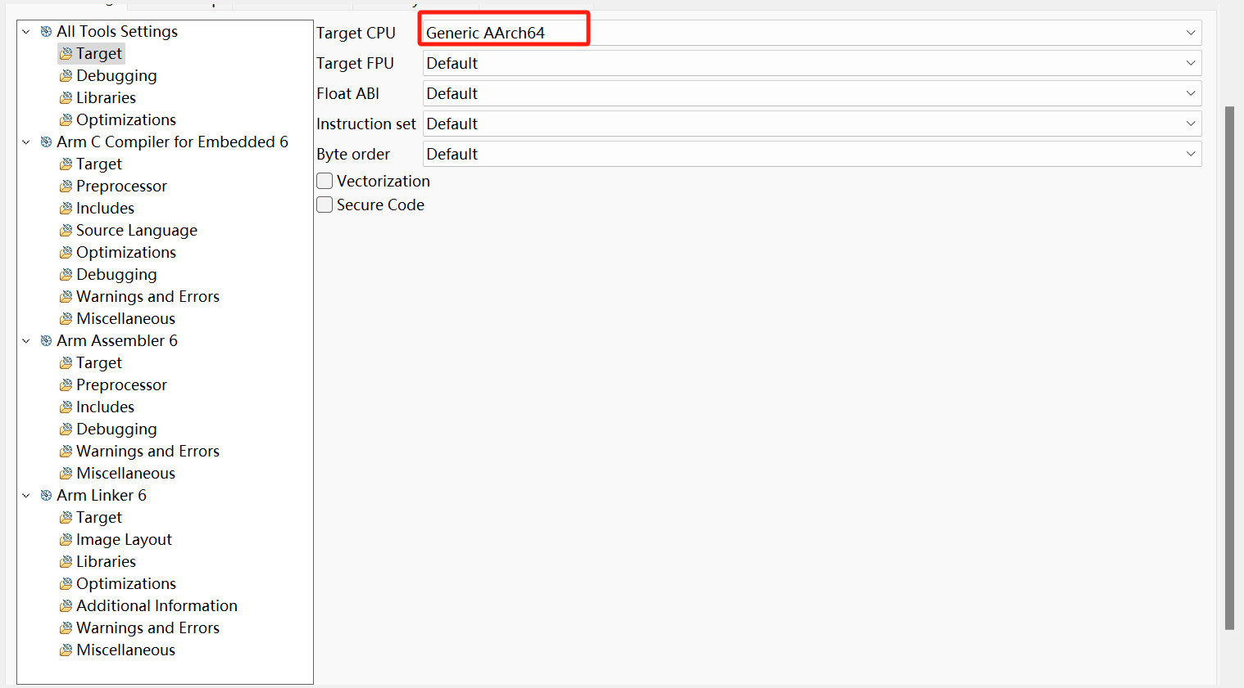

Figure 61

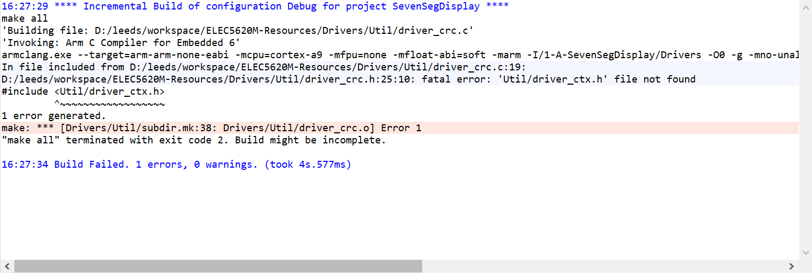

Figure 62

**DE1SoC_SevenSeg/DE1SoC_SevenSeg.c**

/*

* DE1SoC_SevenSeg.c

*

* Created on: 12 Feb 2021

* Author: Harry Clegg

* Updated on: 06 Mar 2024

* Author: David Cowell

* Junnan Liu

*/

#include "DE1SoC_SevenSeg.h"

// Address assignment for different values of value

// Using the display_mapping table to record

// the value will be better than the switch case

// Since the table will significantly reduce the use of jump instruction.

static const unsigned char display_mapping**[]** **=** **{**

0x3F**,** // 0

0x06**,** // 1

0x5B**,** // 2

0x4F**,** // 3

0x66**,** // 4

0x6D**,** // 5

0x7D**,** // 6

0x07**,** // 7

0x7F**,** // 8

0x6F**,** // 9

0x77**,** // A

0x7C**,** // B

0x39**,** // C

0x5E**,** // D

0x79**,** // E

0x71 // F

**};**

// ToDo: Add the base addresses of the seven segment display peripherals.

// 7-segment HEX[3], HEX[2], HEX[1] & HEX[0] Displays.

volatile unsigned char **\***sevenseg_base_lo_ptr **=** **(**unsigned char **\*)**0xFF200020**;**

// 7-segment HEX[5] & HEX[4] Displays.

volatile unsigned char **\***sevenseg_base_hi_ptr **=** **(**unsigned char **\*)**0xFF200030**;**

// There are four HEX displays attached to the low (first) address.

#define SEVENSEG_N_DISPLAYS_LO 4

// There are two HEX displays attached to the high (second) address.

#define SEVENSEG_N_DISPLAYS_HI 2

// The maximum value that a single picture tube can achieve

#define SEVENSEG_N_SINGLE_RANGE 15

// The default value

#define SEVENSEG_N_DEFAULT_NUM 16

// The default display

#define SEVENSEG_N_DEFAULT_DISPLAY 0x40

// The maximum value that the DoubleHex can achieve

#define SEVENSEG_N_DOUBLEHEX_RANGE 0xff

// The maximum value that the DoubeDec can achieve

#define SEVENSEG_N_DOUBLEDEC_RANGE 0x63

void DE1SoC_SevenSeg_Write**(**unsigned int display**,** unsigned char value**)** **{**

// Select between the two addresses so that

// the higher level functions

// have a seamless interface.

**if** **(**display **<** SEVENSEG_N_DISPLAYS_LO**)** **{**

// If we are targeting a low address,

// use byte addressing to access

// directly.

sevenseg_base_lo_ptr**[**display**]** **=** value**;**

**}** **else** **{**

// If we are targeting a high address,

// shift down so byte addressing

// works.

display **=** display **-** SEVENSEG_N_DISPLAYS_LO**;**

sevenseg_base_hi_ptr**[**display**]** **=** value**;**

**}**

**}**

void DE1SoC_SevenSeg_SetSingle**(**unsigned int display**,** unsigned int value**)** **{**

// ToDo: Write the code for driving a

// single seven segment display here.

// Your function should turn a real

// value 0-F into the correctly encoded

// bits to enable the correct segments on the seven segment display to

// illuminate. Use the DE1SoC_SevenSeg_Write

// function you created earlier

// to set the bits of the display.

// If the value is lower or equal than 0xF

**if(**value **<=** SEVENSEG_N_SINGLE_RANGE**){**

// Recall the DE1SoC_SevenSeg_Write

// to write the value into address recorded in display

DE1SoC_SevenSeg_Write**(**display**,**display_mapping**[**value**]);**

**}**

**else{**

// Else it is the default condition.

DE1SoC_SevenSeg_Write**(**display**,**SEVENSEG_N_DEFAULT_DISPLAY**);**

**}**

**}**

void DE1SoC_SevenSeg_SetDoubleHex**(**unsigned int display**,** unsigned int value**)** **{**

// ToDo: Write the code for setting a pair of seven segment displays

// here. Good coding practice suggests your solution should call

// DE1SoC_SevenSeg_SetSingle() twice.

// This function should show the first digit of a HEXADECIMAL number on

// the specified 'display', and the second digit on the display to

// the left of the specified display.

/** Some examples:

*

* input | output | HEX(N+1) | HEX(N)

* ----- | ------ | -------- | ------

* 5 | 05 | 0 | 5

* 30 | 1E | 1 | E

* 0x60 | 60 | 6 | 0

*/

// If the value is bigger than 0xff, it will be default condition.

**if(**value **>** SEVENSEG_N_DOUBLEHEX_RANGE**){**

// Then it will use 16 to let the led

// whose address is related to display became "-".

DE1SoC_SevenSeg_SetSingle**(**display**,**SEVENSEG_N_DEFAULT_NUM**);**

// Second bit also is "-"

DE1SoC_SevenSeg_SetSingle**(**display**+**1**,**SEVENSEG_N_DEFAULT_NUM**);**

**}**

**else{**

// First bit's range is around 0 to 0xF

// Thus just need to let value & 0xf to calculate the first bit

DE1SoC_SevenSeg_SetSingle**(**display**,**value **&** 0xf**);**

// The second bit is the same principle

// Just need to & 0xF0 and then shift 4 bits

// and make this value to address in display+1.

DE1SoC_SevenSeg_SetSingle**(**display**+**1**,(**value **&** 0xf0**)>>**4**);**

**}**

**}**

void DE1SoC_SevenSeg_SetDoubleDec**(**unsigned int display**,** unsigned int value**)** **{**

// ToDo: Write the code for setting a pair of seven segment displays

// here. Good coding practice suggests your solution should call

// DE1SoC_SevenSeg_SetSingle() twice.

// This function should show the first digit of a DECIMAL number on

// the specified 'display', and the second digit on the display to

// the left of the specified display.

/** Some examples:

*

* input | output | HEX(N+1) | HEX(N)

* ----- | ------ | -------- | ------

* 5 | 05 | 0 | 5

* 30 | 30 | 3 | 0

* 0x60 | 96 | 9 | 6

*/

// If the value is bigger than 0x63 (99), it will be default condition.

**if(**value **>** SEVENSEG_N_DOUBLEDEC_RANGE **){**

// Then it will use SEVENSEG_N_DEFAULT_NUM to let the led

// whose address is related to display became "-".

DE1SoC_SevenSeg_SetSingle**(**display**,**SEVENSEG_N_DEFAULT_NUM**);**

// Second bit also is "-"

DE1SoC_SevenSeg_SetSingle**(**display**+**1**,**SEVENSEG_N_DEFAULT_NUM**);**

**}**

**else{**

// First bit's range is around 0 to 9

// Thus just need to let value % 10 to calculate the first bit

DE1SoC_SevenSeg_SetSingle**(**display**,**value **%** 10**);**

// The second bit is the same principle

// Just need to / 10 and then % 10 and

// make this value to address in display+1.

DE1SoC_SevenSeg_SetSingle**(**display**+**1**,(**value **/** 10**)** **%** 10**);**

**}**

**}**

**Reference:**

**main.c**

/**

* main.c

*

* Created on: 12 Feb 2021

* Author: Harry Clegg

* Updated on: 24 Feb 2024

* Author: David Cowell

*/

**DE1SoC_SevenSeg/DE1SoC_SevenSeg.h**

/*

* DE1SoC_SevenSeg.h

*

* Created on: 12 Feb 2021

* Author: Harry Clegg

* Updated on: 24 Feb 2024

* Author: David Cowell

*/